FOR IMMEDIATE RELEASE
DECEMBER 29, 2020
Media Contact:
Holden Armstrong, NDVA Communications Director
402-219-1704
holden.armstrong@nebraska.gov

NDVA Launches ‘Vets Get Pets’ License Plate to Raise Funds for Veteran Pet Adoptions
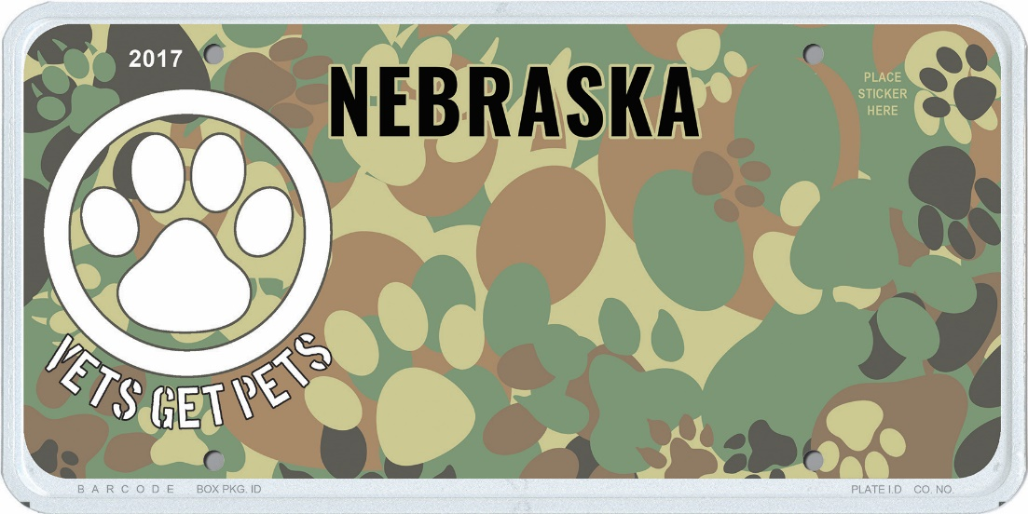
Image of the Vets Get Pets license plate design.
December 29, 2020 (Neb.) — The Nebraska Department of Veterans’ Affairs (NDVA) is launching a new “Vets Get Pets” program to help pay veterans’ animal adoption fees through the sale of special license plates. Starting January 1, 2021, the new “Vets Get Pets” license plate design will be available for all Nebraska drivers to purchase. The plates will cost $5 for the alphanumeric version or $40 for custom message plates. Proceeds from the sale of these plates will be used to fund an adoption fee reimbursement program for veterans, which will launch July 1, 2021, pending sufficient plate sales.

“Our agency is very excited about the ‘Vets Get Pets’ program and the opportunity to provide a new service for our state’s veterans,” said NDVA Director John Hilgert. “As an adopted pet owner myself, I can speak to the joy animals bring to our lives, and multiple studies have illustrated the value of animal companions, particularly in dealing with PTSD. This will be a great service for our veterans and an opportunity for our citizens to support them.”

The “Vets Get Pets” specialty plates can be purchased through dmv.nebraska.gov. Purchase of the plates is open to all Nebraskans, not just veterans, with proceeds from sales going towards veterans’ adoption fee reimbursements. Veterans who have registered with the Nebraska Veterans’ Registry can apply to have up to $350 of pet adoption fee costs reimbursed through the program. Additional information on the “Vets Get Pets” program can be found at veterans.nebraska.gov/vetsgetpets.

The “Vets Get Pets” plate was introduced by Senator Anna Wishart in Legislative Bill 1139, which was amended into LB 944 along with several other new license plates. LB 944 passed the Legislature July 31, 2020, and was signed by Governor Ricketts on August 6, 2020.

###

