**For Immediate Release:**

**3:50PM CT on February 5, 2020**

**Media Contacts:**

**Justin Pinkerman, Governor’s Office, 402-471-1967**

**Holden Armstrong, NDVA, 402-219-1704**

**Vicki Kramer, NDOT, 402-479-4512**

**Daryl Harrison, Nebraska Medal of Honor Foundation, 402-922-1329**

***Media Release:***

**Gov. Ricketts Designates US-20 as “Nebraska Medal of Honor Highway”**

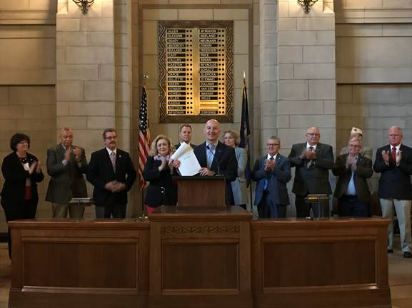

***Governor Ricketts signed paperwork to formally name U.S. Highway 20 as the***

***“Nebraska Medal of Honor Highway” during Veterans Legislative Day at the Nebraska State Capitol.***

**LINCOLN –** On Friday, January 31st, Governor Pete Ricketts signed paperwork to formally name Nebraska’s section of U.S. Highway 20 as the “Nebraska Medal of Honor Highway.”  The signing took place on Veterans Legislative Day, an annual event at the State Capitol for veterans and veteran service organizations to learn about veteran- and military-related legislation.

“Naming US-20 as the ‘Nebraska Medal of Honor Highway’ pays homage to our nation’s most heroic soldiers,” said Gov. Ricketts.  “It’s a fitting way for Nebraska to show respect and appreciation to our veterans for their sacrifices to keep us safe.”

The Nebraska Medal of Honor Foundation applied for the naming of US-20, which the Nebraska Highway Commission then recommended in December.  Nebraska Department of Transportation (NDOT) Director Kyle Schneweis signed the recommendation before submitting the name change to the Governor for approval.

By designating US-20 as the Nebraska Medal of Honor Highway, Nebraska joins a national effort to name US-20, which runs 3,365 miles from Boston, MA to Newport, OR.  Nebraska is home to 432 miles of US-20 and is the fifth state to formally adopt the Medal of Honor name.  Oregon, Idaho, Montana, and Wyoming have already named their sections, and efforts are underway in Iowa, Illinois, Indiana, Ohio, Pennsylvania, New York, and Massachusetts to name their portions as well.

“I’m proud of Nebraska for taking this step to link arms with our neighbors and fellow Americans and be part of a national tribute to our heroes,” said Nebraska Department of Veterans’ Affairs (NDVA) Director John Hilgert.  “This highway runs from coast to coast, crossing widely different terrains and connecting very different people, yet we remain united in our desire to pay tribute to our heroes.  That is a powerful message.”

Since the Medal of Honor was first presented during the Civil War, 3,508 awards have been issued with every state represented.  As of December 21, 2019, there were only 71 Medal of Honor recipients living in the United States of America.  To earn the Medal of Honor, a member of the U.S. Armed Forces must act with “conspicuous gallantry and intrepidity above and beyond the call of duty during combat at the risk of one’s life against an enemy of the United States.”

“This is a means of paying tribute to all Nebraska Medal of Honor recipients and is a gift to them and treasure to Nebraska by all Nebraska veterans and patriots,” said Nebraska Medal of Honor Foundation President Daryl Harrison.  “Now the Nebraska Medal of Honor Foundation has the work before it to ensure signage along the Nebraska Medal of Honor Highway properly pays tribute to Nebraska’s greatest warriors.”

The US-20 segment running from Fort Robinson State Park to Hay Springs will retain its name as Crazy Horse Memorial Highway.

A list of Nebraska’s currently named highways and bridges is available [here](https://dot.nebraska.gov/media/2865/named-hwy-list.pdf).

**###**