FOR IMMEDIATE RELEASE
APRIL 19, 2023
Contact:
Holden Armstrong, NDVA Communications Director
402-219-1704, holden.armstrong@nebraska.gov
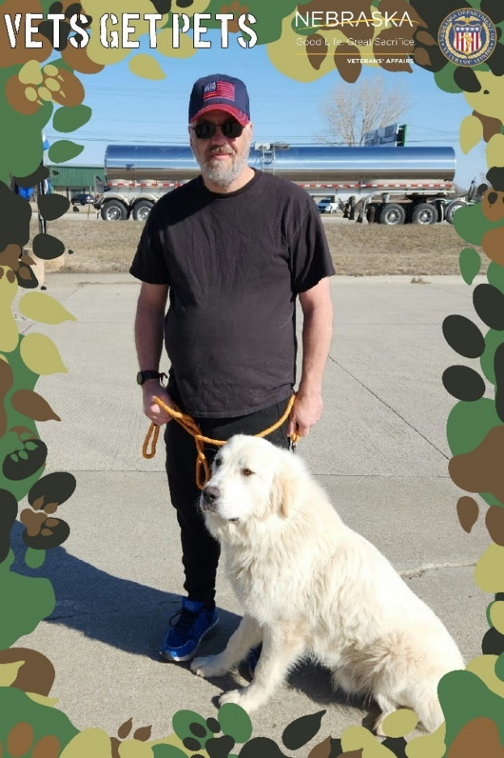
NDVA Celebrates 50th Vets Get Pets Adoption
Army veteran Scott Henry with Bear, the 50th rescue animal to be adopted through NDVA’s Vets Get Pets program. More photos here.

Neb. — On March 28, Army veteran Scott Henry adopted Chicken Alfredo (who now goes by Bear) from the Animal Shelter of Northeast Nebraska, making Bear the 50th adoption to be facilitated through the Nebraska Department of Veterans’ Affairs (NDVA) Vets Get Pets program.

Henry, who served in the Military Police Corps in the late 90s, suffered a stroke in 2021, leading to stability issues. During a visit to the Bellevue University’s Military and Veteran Services Center he learned about JAVELAN, a program that helps train and provide service dogs for veterans and retired first responders, and NDVA’s Vets Get Pets program which could help cover his adoption fees.

“I love the Vets Get Pets program. There are a lot of veterans out there who just need a companion to help fight loneliness or give you something to do—a reason to get out of the house,” Henry said. “Bear can help prevent falls or help me get up from falls, but he’s also a great dog. He’s great with my grandkids and a big fuzzy friend. I want there to be a thousand Vets Get Pets adoptions by the end of the year.”

Helping Vets Get Pets

Vets Get Pets was created by the Nebraska Legislature in 2020. Senator Anna Wishart championed the program as well as a specialty license plate to provide necessary funding. Her bill was amended into LB 944, which was approved by the Legislature and signed by Governor Pete Ricketts on August 6, 2020. Vets Get Pets license plates went on sale January 1, 2021, and the first pet adoption, an Australian cattle dog/husky mix named Donatello, was finalized July 23, 2021.

“The response to Vets Get Pets has been overwhelmingly positive,” said NDVA Director John Hilgert. “It’s one of the more fun programs NDVA administers, but the impact is real and the feedback we’ve gotten from veterans who have utilized it is tremendous. Companion animals can do so much to enrich our lives, and we’re excited to hear more stories like Private Henry’s as we help more veterans get pets.”
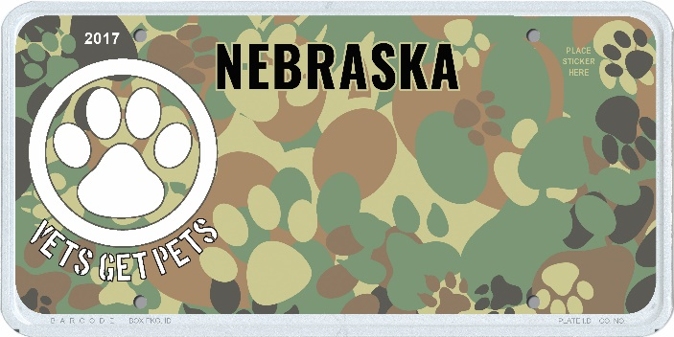
Through Vets Get Pets, Nebraska veterans can have up to $350 in rescue pet adoption fees covered. To be eligible, they must apply to the Nebraska Veterans’ Registry to verify their veteran status and adopt from an organization registered with the Nebraska Rescue Council. There is no requirement that the pet be a service animal.

Funding for the program comes from the sale of Vets Get Pets license plates, which are available to purchase through the Nebraska DMV. Plates cost $5 for the alphanumeric version or $40 for a custom message. To date, nearly 1,000 specialty plates have been purchased by Nebraska drivers to help support the program.

Information about utilizing Vets Get Pets to cover adoption fees, as well as details on purchasing a license plate can be found at veterans.nebraska.gov/vetsgetpets.

A Second Chance for Bear

The Vets Get Pets program has had support from a number of Nebraska animal rescues, including the Animal Shelter of Northeast Nebraska, where Henry adopted Bear. “This is one small thing we can do to recognize our veterans’ sacrifices,” said Lisa Doescher, the manager of the shelter, who is herself a veteran. “It may seem small to some, but it means the world to others. Everybody deserves a second chance. Every animal that comes here was unwanted and these animals deserve a second chance. In some ways it’s a second chance for the veterans who adopt them, too.”

Bear, a white, two-and-a-half-year-old Great Pyrenees, is one of those second chances. He was found as a stray in Texas and sent to a shelter there where he ended up on the euthanasia list. Luckily for Bear, the Animal Shelter of Northeast Nebraska has partnerships with several shelters and brings animals to Nebraska when it identifies a good match. When Henry visited the shelter and explained he was looking for a dog through the JAVELAN program, Doescher thought of Bear. She contacted the shelter in Texas, and volunteers drove Bear the 14 hours to Norfolk to meet Henry. They turned out to be a perfect match. Then, JAVELAN sent a trainer to do a behavioral assessment to determine if Bear was a good fit for its program. He was. Now, Henry and Bear are set to start the JAVELAN program in late April.

Founded as a non-profit in 2017 and now part of First Responders Foundation, JAVELAN is focused on connecting veterans and retired first responders with service dogs and providing the necessary training to both the dog and the handler. The community-based training lasts between three and six months and comes with lifetime support, should the need for additional training or retraining arise.

“I’ve seen the difference these dogs can make in people’s lives and have gone through that experience,” said JAVELAN co-founder Bob Dean. “We recently trained our 100th team which is quite a milestone for us. We want to give back to the veterans and first responders who have done so much for us, so we’ll do everything we can to connect and train them.”

What Could Be Better?

Several studies have shown the health benefits of pet ownership, including studies done at the U.S. Department of Veterans Affairs and Centers for Disease Control and Prevention. These benefits can include reductions in depression, anxiety, and loneliness, as well as increased opportunities for exercise and social interaction.

“I want everyone to know about this program,” Henry said. “There are people like me with a family and grandkids, and another grandkid on the way, but there are other veterans out there who don’t have that. I want them to know about Vets Get Pets and that they can get a pet like Bear for free. What could be better?”

###

