FOR IMMEDIATE RELEASE
FEBRUARY 21, 2023
Media Contact:
Holden Armstrong, NDVA Communications Director
402-219-1704
holden.armstrong@nebraska.gov
NDVA Receives Abraham Lincoln Pillars of Excellence Award for Virtual Claims Clinic Initiative
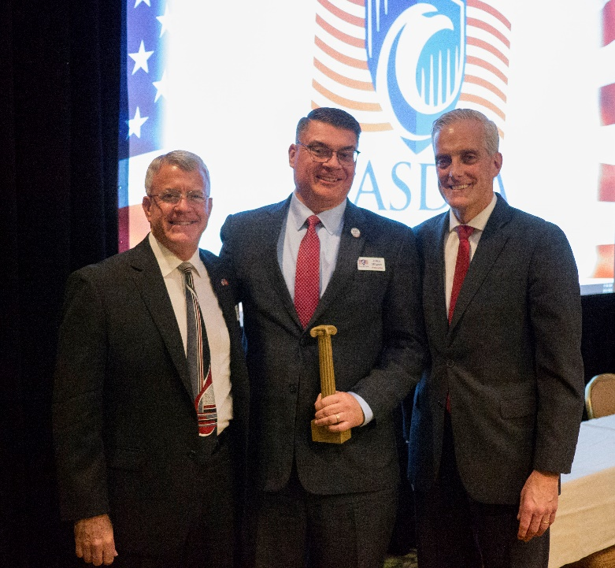
NDVA Director John Hilgert receiving Abraham Lincoln Pillars of Excellence Award from VA Secretary Denis McDonough (right) and NASDVA President James Hartsell of Florida (left).
WASHINGTON (Feb. 21, 2023) — On Tuesday, U.S. Department of Veterans Affairs (VA) Secretary Denis McDonough presented the Nebraska Department of Veterans’ Affairs (NDVA) with an Abraham Lincoln Pillars of Excellence award in recognition of the agency’s virtual claims clinic initiative.

Initially developed to assist veterans with pending claims during the COVID-19 pandemic, virtual claims clinics are a collaboration between NDVA, the Veterans Benefit Administration (VBA), and county veterans service officers (CVSOs) and have been continued due to their success. To date, they have resulted in nearly $2.9 million in retroactive benefits being recovered and paid to Nebraska veterans and family members.

“I want to thank and congratulate the many partners who have helped make this initiative a success,” said NDVA Director John Hilgert. “What started as a way for our state service office, CVSOs, and VBA to continue serving our state’s veterans and their families during the COVID-19 pandemic has been carried forward because everyone saw its value.”

A wide range of claims can be processed during a virtual claims clinic. Prior to the clinic, NDVA works with VBA to identify pending claims in the Veteran Benefit Management System and CVSOs conduct reviews of pending claims they have submitted for veterans in their counties. During the clinic, NDVA, VBA, and participating CVSOs work in collaboration to move the identified claims forward in the process by determining missing information, requesting a compensation and pension (C&P) exam, or resolving a variety of other issues.

“The Sarpy County Veterans Service Office greatly appreciates the efforts of NDVA in hosting the virtual claims clinics,” said Sarpy County Veterans Service Office Director Matthew MacDonald. “These events typically allow us, as veterans advocates, to get resolution on claims that have been lingering in the VA system for extended periods or claims that need resolution for various reasons. The virtual claim clinics are always a resounding success for not only our office, but for countless service organizations in Nebraska.”
Veterans with pending claims they would like reviewed in an upcoming virtual claims clinic can contact their CVSO (a directory is available at veterans.nebraska.gov/cvso) or the NDVA State Service Office at 402-420-4021 or ndva.sso@nebraska.gov. There are typically three to four clinics held each year.

“From the very first virtual claims clinic, it has been very easy to get some movement on ready-for-decision pending claims, as well as the most recent submitted claims,” said Ken Stenka, veteran service officer for Holt, Boyd, and Wheeler counties. “It also opens the communications to the Regional Office with words of advice, helpful suggestions, and/or different perspectives on claims. The clinics seem to be very well run and communicated back to the CVSOs. This has been an asset for the service officers as well as a great tool moving into future claims! Thank you for looking outside of the box and finding ways to improve the system.”
The Abraham Lincoln Pillars of Excellence Award is a recognition program developed by the VA Office of Intergovernmental Affairs and the National Association of State Directors of Veterans Affairs (NASDVA). The award allows VA and NASDVA to evaluate state programs to establish best practices and provide a model for other state agencies to follow for greater success and efficiency in serving and supporting our nation’s veterans and their families. Award categories include customer experience with VA benefits and services, eliminating veteran homelessness, suicide awareness and prevention, delivery of services to tribal governments serving Native American Veterans, innovative state programs, and eliminating the claims and appeals backlog, which is the category NDVA’s award fell under. Nebraska was among eight states to be recognized with a Pillars of Excellence award this year at the NASDVA Midwinter Training Conference in Washington, D.C.
###

