FOR IMMEDIATE RELEASE
JULY 19, 2022
Media Contact:
Holden Armstrong, NDVA Communications Director
402-219-1704
holden.armstrong@nebraska.gov
Call for Art Entries for Nebraska Women Veterans Symposium
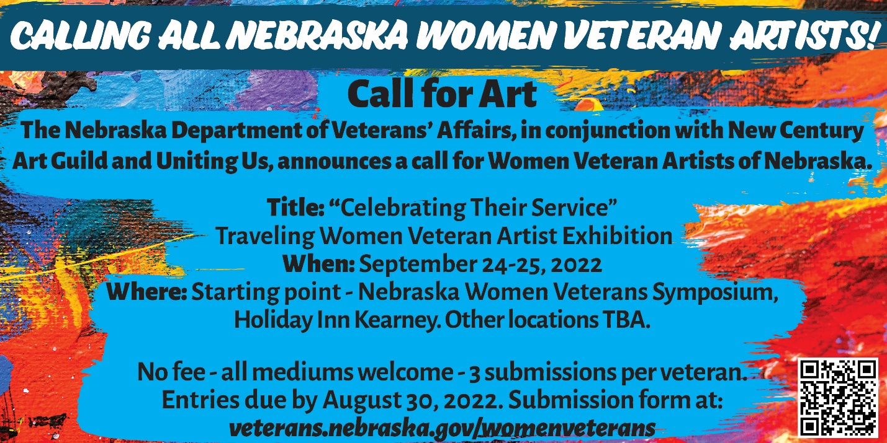
Lincoln, Neb. — The Nebraska Department of Veterans’ Affairs (NDVA), in conjunction with New Century Art Guild and Uniting Us, announces a call for women veteran artists of Nebraska to submit artwork to the “Celebrating Their Service” traveling women veteran artist exhibition. All mediums are welcome, with three submissions allowed per veteran. Submissions are due by August 30, 2022.
“The number of women veterans is growing rapidly, as is their use of the VA for healthcare,” said NDVA Women Veterans Coordinator Erin Colson. “Stories of their military service deserve greater attention, and many women veterans tell these stories through art which can be a very therapeutic process, helping veterans cope with many issues, both physical and mental.”
The art exhibition’s starting point will be at the Nebraska Women Veterans Symposium at the Holiday Inn in Kearney on September 24-25, after which it will travel the state (future locations to be announced). A submission form and additional details are available at veterans.nebraska.gov/womenveterans. For questions about the exhibition or submitting artwork, please contact Erin Colson at Erin.Colson@va.gov or Troy Muller at TMuller@newcenturyartguild.org.
Nebraska Women Veterans Symposium
Nearly half of the 200 spots available for the free, two-day symposium for Nebraska women veterans have been filled. Registration is available at veterans.nebraska.gov/womenveterans and is open until the date of the event or when all spots are filled.
Past National Commander of the American Legion Denise Rohan, who was the first woman to be elected to the top position of the American Legion, will be the keynote speaker. Leaders in the women veterans and military community will take part in a panel discussion titled “Celebrating Who I Was and Who I’ve Become,” about the struggles women veterans face both while serving in the Armed Forces and while transitioning out of the service. Other activities include a journaling exercise with Warrior Writers, an art activity with New Century Art Guild, interviews for the Library of Congress Veterans History Project, and a screening of Lioness, a documentary about a group of female Army support soldiers who were part of the first program in American history to send women into direct ground combat.
Additional presenters include:
- Nebraska/Western Iowa Women Veterans
- Veterans Health Administration (VHA)
- Veterans Benefits Administration (VBA)
- Women Veterans Program Manager for Nebraska/Western Iowa VA Healthcare System
- Homeless Veteran Coordinator
- Veteran Readiness and Employment (VRE)
- Vet Center
- VFW Nebraska
- American Legion Nebraska
- HETRA
- Hearts for Healing
- New Century Art Guild
- Uniting Us
- Wounded Warrior Family Support
- Wounded Warrior Project
The event is hosted by the Nebraska VFW and NDVA. Financial support for the conference has come from Nebraska VFW Foundation and PenFed Foundation.

###

