FOR IMMEDIATE RELEASE
OCTOBER 29, 2021
Media Contacts:
Holden Armstrong, NDVA Communications Director
402-219-1704
holden.armstrong@nebraska.gov
Jay B. Sloan, Director of Operations & Marketing, NIC Nebraska
Jay.sloan@egov.com

Nebraska Department of Veterans’ Affairs Presented with dotCOMM Gold Award for New Website
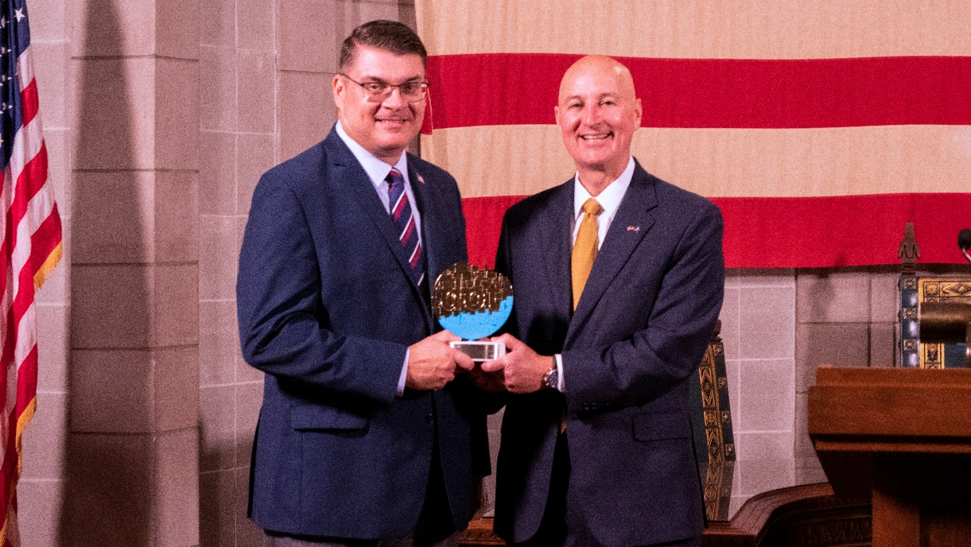
Governor Ricketts (right) and NDVA Director John Hilgert (left) with the dotCOMM Gold Award. Video of the presentation is available here.
OCTOBER 27, 2021 (LINCOLN, Neb.) — On Wednesday, October 27, Governor Pete Ricketts and Nebraska Department of Veterans’ Affairs (NDVA) Director John Hilgert accepted a dotCOMM Gold Award for the new NDVA website, veterans.nebraska.gov, that launched in July 2020.
The NDVA website, developed by NIC Nebraska, a part of the NIC division of Tyler Technologies, Inc., received recognition for making benefits and services more easily accessible to the state’s veterans. Using new and innovative technology, the NDVA website helps streamline veterans’ ability to connect with the agency and makes navigating available benefits more efficient.
“An unknown and unused benefit doesn’t serve our veterans or their families. Part of our mission is to make veteran benefits and services easy to find and access, and our new website allows us to better do that,” said NDVA Director John Hilgert. “This project was a team effort, and I want to commend everyone at NIC Nebraska and within our team at NDVA who collaborated to make this a success. The result is something that better serves Nebraska’s veterans and that’s apparent from the recognition our website is receiving today.”
The NDVA website offers veterans a wide array of services and information in a centralized, easy-to-use platform. Through the Nebraska Veterans’ Gateway to Employment, veterans can access a suite of employment tools, including a resource expert to guide users through the large number of employment and training resources available to veterans and their families, a job converter that finds civilian equivalents to military occupational service codes, a job search provided through NEWorks, and additional resources from the USVA, Nebraska Department of Labor, and Nebraska State Jobs.

In addition to the Nebraska Veterans’ Gateway, several other tools and enhancements were added to the website.

- A new Benefits Expert system is available that guides users through the wide range of county, state, and federal benefits and services available to veterans and their family members.
- An interactive behavioral and mental health services map allows users to find and filter services from across the state related to aging and disability, community support, emergency shelter and housing, mental health, substance abuse treatment, and transportation.
- The Virtual Veteran Service Officer system, announced in May enables users to chat with an accredited state service officer Monday through Friday, 8:00 a.m. to 6:00 p.m., and get help with any service offered at the physical state service office.
- The revamped County Veteran Service Officer (CVSO) directory now includes a clickable map to easily pull up any county’s CVSO information.

“NIC Nebraska was honored to partner with the Nebraska Department of Veterans’ Affairs on this very important project said Brent Hoffman, general manager of NIC Nebraska. “NIC is proud to have worked on a project that will make services and benefits to Nebraska veterans more convenient and accessible.”
NIC Nebraska also announced the NDVA website was recently recognized with two additional awards this week, including a Davey Award for outstanding creative work and a MarCom Award for excellence in marketing and communications.
The dotCOMM Awards is an international competition administered by the Association of Marketing and Communication Professionals (AMCP) that seeks to honor excellence in web creativity and digital communication. Winning a dotCOMM award signifies to employers, clients, prospects, and competitors that the winner’s web and digital work is among the best in the industry. The dotCOMM Awards is administered and judged by the AMCP, one of the largest, oldest, and most respected evaluators of creative work in the marketing and communication industry.
###

