FOR IMMEDIATE RELEASE
JULY 1, 2021
Media Contact:
Holden Armstrong, NDVA Communications Director
402-219-1704
holden.armstrong@nebraska.gov

NDVA Opens ‘Vets Get Pets’ Veteran Pet Adoption Fee Payment Program
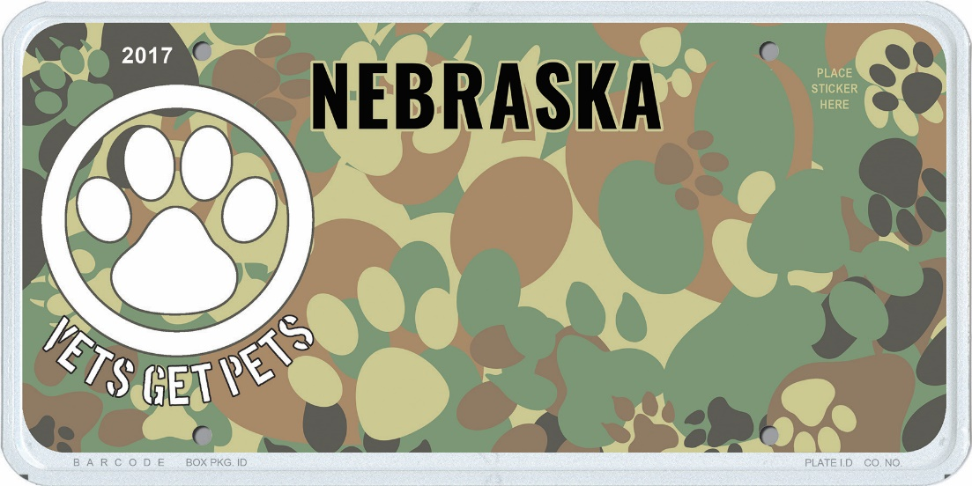
Image of the Vets Get Pets license plate design.
JULY 1, 2021 (Neb.) — Nebraska veterans can now apply to have up to $350 in eligible pet adoption fees paid through the Nebraska Department of Veterans’ Affairs (NDVA) Vets Get Pets program. Veterans must be registered in the Nebraska Veterans’ Registry and adopt from an organization registered with the Nebraska Rescue Council. Once approved, NDVA will disburse funds directly to the adoption organization to cover up to $350 of the cost of a pet’s adoption. Full details on the Vets Get Pets program, including how to join the registry, which animal rescues qualify, and how to apply, can be found at veterans.nebraska.gov/vetsgetpets.

“We’re excited to offer this new benefit to Nebraska veterans,” said NDVA Director John Hilgert. “It really is a win across the board, for our state’s veterans and their families, for animal rescues throughout the state, and for the pets that will be adopted. We want to thank all the Nebraskans who have purchased a Vets Get Pets plate because those funds are what make this program possible.”

The Vets Get Pets license plate launched January 1, 2021, with proceeds from the plate’s sale going to fund the adoption fee program for Nebraska veterans. As of June 30, 2021, 376 of the specialty plates have been purchased by Nebraska drivers. The Vets Get Pets license plates are available for purchase through dmv.nebraska.gov and cost $5 for the alphanumeric version or $40 for the custom message version.

The Vets Get Pets license plate and program was introduced by Senator Anna Wishart in Legislative Bill 1139, which was amended into LB 944 along with several other new license plates. LB 944 passed the Legislature July 31, 2020, and was signed by Governor Ricketts on August 6, 2020.

###

