FOR IMMEDIATE RELEASE
July 23, 2020
Media Contact:
Holden Armstrong, NDVA Communications Director
402-219-1704
holden.armstrong@nebraska.gov

NDVA Announces New Website, Eastern Nebraska Veterans’ Home Expansion, and Enhanced Welcome Home Initiative
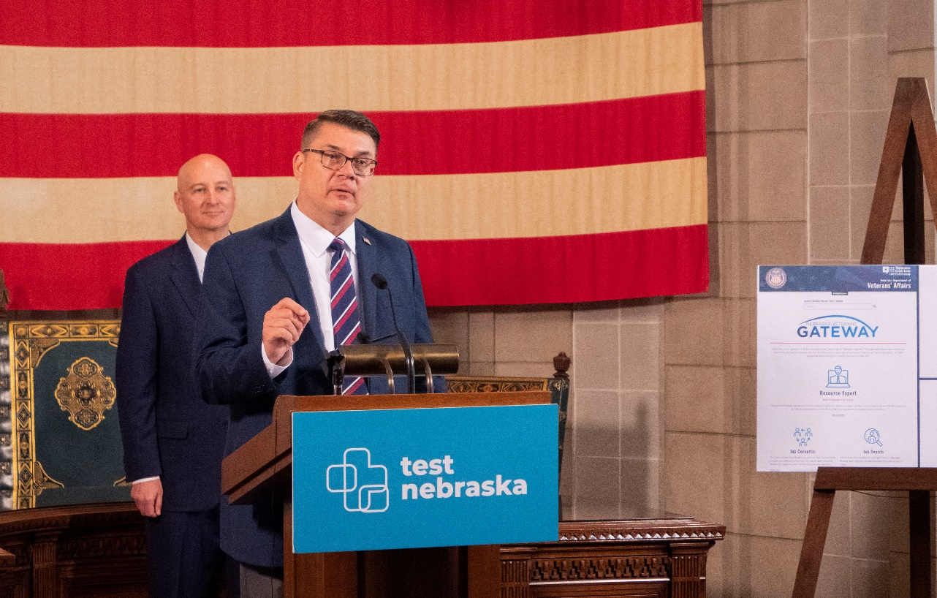
NDVA Director John Hilgert gives updates on the new veterans.nebraska.gov website at today’s briefing.

JULY 23 (LINCOLN, Neb.) — Today, the Nebraska Department of Veterans’ Affairs (NDVA) joined Governor Ricketts to announce the launch of its new website, plans for an expansion at the Eastern Nebraska Veterans’ Home, and enhancements to the “Welcome Home” initiative for discharging service members.

“Today is very exciting for our agency as we take some of the tools and resources we use to serve Nebraska’s veterans to the next level,” said NDVA Director John Hilgert. “I am proud of my entire team for the energy they put towards improving what we have, building new tools, and always having the veteran in mind as we move forward.”

New NDVA Website

In 2019, the Legislature passed LB138 which tasked NDVA with developing a website with veteran-specific job search tools. As part of the new website, NDVA created the Nebraska Veterans’ Gateway, which features a suite of tools to help veteran job seekers. It includes a resource expert to guide users through the large number of employment and training resources available to veterans and their families, a job converter that finds civilian equivalents to military occupational service codes, a job search provided through NEWorks, and additional resources from the USVA, Nebraska Department of Labor, and Nebraska State Jobs.

In addition to the Nebraska Veterans’ Gateway, several other tools and enhancements were added to the website.

- A new Benefits Expert A.I. system is available that guides users through the wide range of county, state, and federal benefits and services available to veterans and their family members.
- An interactive behavioral and mental health services map allows users to find and filter services from across the state related to aging and disability, community support, emergency shelter and housing, mental health, substance abuse treatment, and transportation.
- The Virtual Veteran Service Officer system, announced in May, is now a permanent feature. Users can to chat with an accredited state service officer Monday through Friday, 8:00 a.m. to 8:00 p.m., and get help with any service offered at the physical state service office.
- The revamped County Veteran Service Officer (CVSO) directory now includes a clickable map to easily pull up any county’s CVSO information.
- The agency’s enhanced news and events page keeps veterans up to date a constant stream of NDVA news and USVA feeds on all veteran happenings.

“The new NDVA website delivers on our mission of providing customer-focused service,” said Gov. Ricketts. “The Nebraska Veterans’ Gateway was built with veterans in mind and is a great tool to help our military families transition to civilian life here in Nebraska. It will aid veterans in accessing benefits and information more effectively and efficiently than ever before.”
The website can be accessed at veterans.nebraska.gov.

Eastern Nebraska Veterans’ Home Expansion

Also announced today were plans for an expansion at the Eastern Nebraska Veterans’ Home (ENVH). The expansion will create 30 new skilled nursing beds at the facility, replace 30 semi-private assisted living beds with 24 private assisted living beds, and provide space to expand services to include an adult day health care program, something not currently offered by NDVA.

“Our team is excited for the expansion and the opportunity to serve more veterans here at our facility,” said ENVH Administrator David Williamson. “The new adult day health care program is especially exciting as it offers a bridge for veterans who don’t need 24/7 care, but do need some support to continue living independently. We think it will help serve them and their families, and are looking forward to being that bridge.”

When ENVH was designed and built in 2005, a future addition was included in the planning. The USVA recently informed NDVA they are eligible for federal grant funding for the project, which would cover 65% of the cost. The State of Nebraska allocated its required portion of the funding—just over $3.3 million—in 2019.

“Welcome Home” Packet

Finally, the agency announced changes that enhance how the state connects with recently discharging members of the U.S. Armed Forces. When service members discharge and return to Nebraska, Governor Ricketts sends them a welcome home letter outlining some of Nebraska’s veteran benefits, encouraging them to contact their CVSO or the NDVA State Service Office, and inviting them to a Welcome Home Picnic in the fall.

NDVA’s new Welcome Home packet will accompany the governor’s letter and include information on county, state, and federal benefits; occupational licensure benefits for veterans, military service members, and their spouses; NDVA programs such as Nebraska Veterans’ Aid, Reservist Tuition Credit, and Waiver of Tuition; NDVA’s Guide to Veterans Benefits that covers applying for a wide range of benefits, appealing claims, and more.

“By putting all of our benefits materials and contact information in the veteran’s hands, we’re eliminating a step for them, and making sure they see what we can do for them,” said State Service Office Manager Levi Bennett. “We want to be a veteran’s first stop in their transition to civilian life and make sure they’re receiving every benefit—whether it’s county, state, or federal—that they’ve earned.”

###

