FOR IMMEDIATE RELEASE
MAY 21, 2020
Media Contacts:
Holden Armstrong, NDVA Communications Director
402-219-1704, holden.armstrong@nebraska.gov
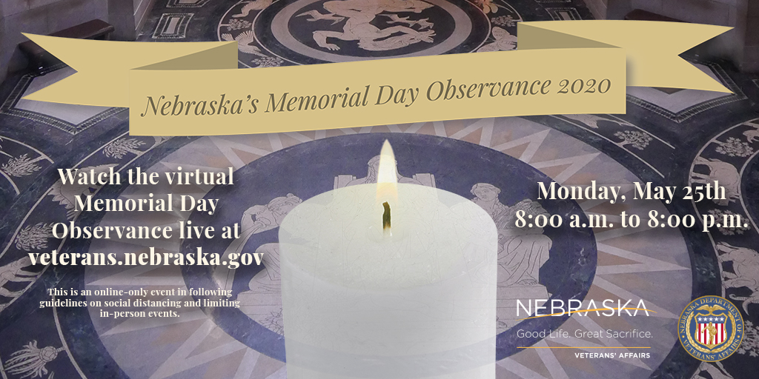
Nebraska’s Memorial Day Observance 2020 Event Goes Live Monday at 8AM
MAY 25, 2020 (Neb.) — The live stream for Nebraska’s 2020 Memorial Day Observance will go online at 8:00 a.m. Monday, May 25th, at veterans.nebraska.gov/memorialday. The Nebraska Department of Veterans’ Affairs (NDVA) is hosting the event and inviting all Nebraskans to attend virtually as in-person events across the state are limited or cancelled by COVID-19.

“Memorial Day is an important event throughout the state, especially in our veterans’ homes,” said NDVA Director John Hilgert. “With in-person events not possible this year, we knew there needed to be an alternative for that reflection and remembrance and wanted to provide something all Nebraskans can participate in.”

The ceremony will begin at 8:00 a.m. with the lighting of a ceremonial candle by Gold Star Mother Monica Alexander and remain lit until her husband, Mel, extinguishes it at 8:00 p.m. Their son, Army Corporal Matthew Alexander, of Gretna, was killed May 6, 2007, when an improvised explosive device detonated near his vehicle in Baqubah Iraq. Over the course of the day, 24 honor guards, in groups of two that are comprised of members of veteran service organizations from across the state, will stand by the candle.

###

