FOR IMMEDIATE RELEASE
AUGUST 10, 2024
Contact:
Holden Armstrong, NDVA Communications Director
402-219-1704, holden.armstrong@nebraska.gov

Gov. Pillen, NDVA Host Veterans and Families at Annual Welcome Home Dinner
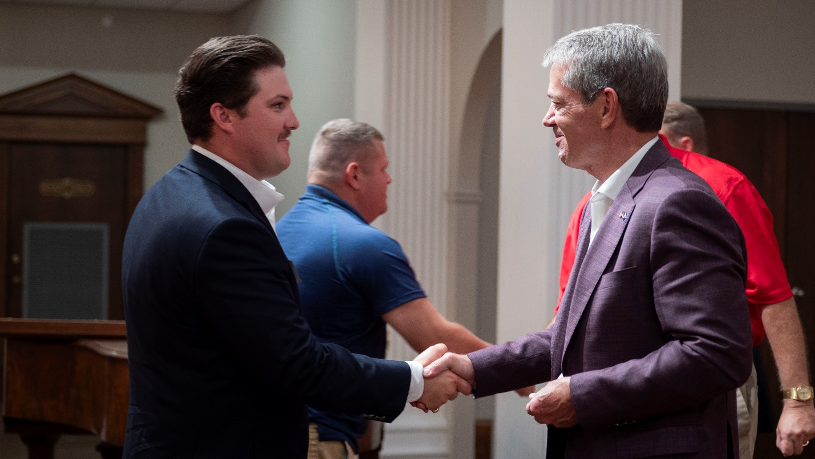
Governor Pillen presents a “Welcome Home” challenge coin to a veteran at the 2024 Welcome Home Dinner. More photos available here.
(LINCOLN, NEB.) — On Friday evening, Governor Jim Pillen hosted veterans and their family members for the state’s annual Welcome Home Dinner. The event, which started in 2016, is co-hosted by the Nebraska Department of Veterans’ Affairs (NDVA) and sponsored by Walmart. Nebraska’s newest veterans—those who discharged from service in the previous 12 months—as well as their families are invited to attend.
Governor Pillen presented each veteran in attendance with a keepsake Welcome Home challenge coin. “We all know the sacrifices our service members and their families make in order to protect our great nation,” said Gov. Pillen. “We want to give them a warm, Nebraska welcome home. It’s a way to thank them and show them all the opportunities and support our state has to offer.”
In addition to veterans and their families, exhibitors from the U.S. Department of Veterans Affairs (VA), state of Nebraska agencies, veterans service organizations, and other veterans support groups and non-profits were on hand to share resources, promote benefits and services, and showcase employment opportunities with attendees.
“Our Welcome Home program includes two parts: a packet that goes out to each returning service member that outlines everything the state of Nebraska and the VA has to offer them and the Governor’s Welcome Home Dinner where we get to meet our state’s newest veterans in person to shake their hand and thank them for their service,” said NDVA Director John Hilgert. “Getting to spend an evening with them to hear their stories, get to know their families, and share the ways we can support them is one of our most exciting and fulfilling events.”
“I wish all veterans the very best as they embark in their next stage of life, and may you enjoy the happiness of knowing you have honorably done your duty and performed a great service for your country,” said MG Strong.
###

