FOR IMMEDIATE RELEASE
OCTOBER 13, 2026
Contact:
Laura Strimple, Governor’s Office - (402) 580-9495
Holden Armstrong, NDVA - (402) 219-1704
Gov. Pillen, Agency Leaders Highlight ‘Good Life is Calling Veterans’ Initiative
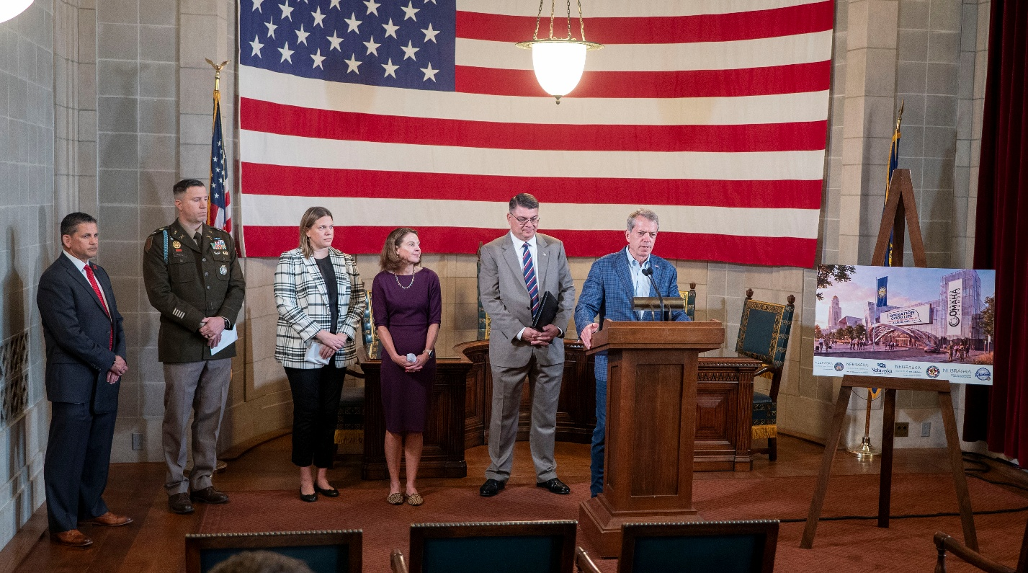
Gov. Pillen introduces the “Good Life is Calling Veterans” recruitment campaign. Behind him, from left to right are UNL Military Relations & Military/Veteran Success Center Executive Director Joe Brownell, Nebraska Army National Guard Recruiting & Retention Battalion Commander LTC Daniel E. Fritz, NDOL Commissioner Katie Thurber, DED Director Maureen Larsen, and NDVA Director John Hilgert. Additional photos are available here.

(LINCOLN, Neb.) — Today, Governor Jim Pillen was joined by leaders and representatives from several state agencies and post-secondary institutions to highlight a new, multi-agency initiative to bring discharging U.S. Armed Forces service members and their families to Nebraska. The “Good Life is Calling Veterans” initiative is run by the Nebraska Commission on Military and Veteran Affairs (CMVA) in partnership with the Nebraska Department of Veterans’ Affairs (NDVA), Nebraska Department of Economic Development (DED), Nebraska Department of Labor (NDOL), Nebraska Department of Education (NDE), and the Nebraska Military Department. Additional partners include post-secondary institutions with NDVA’s “Veteran & Active Duty Supportive” designation.
“What makes Nebraska great is the people, and I want to commend the Commission on Military and Veteran Affairs and each of our state agencies which are making sure we are telling that story to our nation’s service members and veterans,” said Gov. Pillen. “We want all of America’s veterans and their families to know Nebraska is here to support them with our benefits, great quality of life, and meaningful job opportunities. When they leave the military, we want their next stop to be Nebraska so they can join us in enjoying the Good Life.”
The initial phase of the “Good Life is Calling Veterans” campaign involves a series of emails sent to U.S. service members who have recently discharged from service or will soon be discharging to encourage them and their families to put down roots in Nebraska and connect them with jobs in the state. Since launching in July 2026, over 85,000 U.S. service members have been contacted with emails covering Nebraska veteran benefits, the state’s high quality-of-life scores, low cost of living, and extensive educational opportunities across Nebraska.
“No other state is doing veteran and military outreach quite like this,” said NDVA Director John Hilgert. “The sheer number of service members and veterans we’re reaching, combined with the public servants at multiple state agencies ready to give them one-on-one attention with a real person rather than simply pointing them to a webpage or chatbot, makes this unique. When you add the upcoming career fairs to ensure they know Nebraska has great jobs for them in addition to the quality of life, educational opportunities, and other benefits, it’s a win for everyone across the board.”
When a veteran requests details about Nebraska or one of the topics covered in the emails, their contact information is sent to the relevant agencies or organizations based on their request so a team member can promptly reach out to answer questions and promote relocating to Nebraska. Each partnering agency is responsible for requests specific to their expertise, with NDVA answering questions on veteran benefits and services, DED providing details on housing opportunities and quality of life in the state, NDOL sharing job opportunities and career resources, NENG recruiters connecting with veterans interested in continuing their military service, and representatives from schools with the “Veteran & Active Duty Supportive Postsecondary Institution” designation sharing education opportunities.
“The Good Life is a great place for veterans. We have an unmatched quality of life, veteran-friendly culture, and rewarding professional opportunities,” said Nebraska DED Director Maureen Larsen. “Upon retiring from military service, many veterans are looking to contribute their skills in the civilian workforce. Through our existing Good Life is Calling campaign, State agencies are partnering to aggressively recruit our nation's finest and their spouses to here to Nebraska.”
In addition to the email outreach campaign, the initiative will also include “Operation Good Life” virtual career fairs for recently separated and soon-to-be separating service members and their spouses. The first of the series is set to be held in mid-December in partnership with the Omaha Chamber of Commerce, with future career fairs focused on other locations throughout the state as well as specific career fields. The online platform will allow participants, even those serving overseas, to easily connect with hundreds of Nebraska-based employers eager to hire from this valuable applicant pool.
“Veterans bring incredible skills and real-world experience to the table, and Nebraska employers are eager to help them put those talents to work,” said Commissioner of Labor Katie Thurber. “Through strategic collaboration, the partners involved in this effort are making it easier than ever for veterans across the country to see the opportunities waiting for them here.”
For service members who are interested in continuing their service rather than jumping into a civilian career or going back to school, NENG recruiters are available to connect and discuss enlistment opportunities and benefits. Former service members are ideal candidates for guard service as they already have training and experience to bring immediate readiness to the guard. They can continue in their current military occupational specialty (MOS) or try a new career path. Some of the other benefits offered for enlistees are tuition assistance, student loan repayment, enlistment bonuses, and tax benefits.
“The Nebraska Military Department applauds the work that the Nebraska Commission on Military and Veterans Affairs is doing to bring Veterans and their families to Nebraska,” said Maj. Gen. Craig Strong, Nebraska adjutant general. “The two strongest desires among returning Veterans is a desire to start their careers and raise their families in Nebraska and a desire to be part of something greater than themselves,” said Strong. “By informing these returning Veterans about the opportunities that are available in the Nebraska National Guard and Nebraska in general, we are showing them that they can do both. They can still use the training and the skills they have developed during their many years of military service in the Nebraska National Guard while also being able to be part of the “Good Life” in Nebraska where they can build a career and raise a family. It’s really a win-win for all of us.”
When service members opt to learn more about education opportunities in Nebraska, representatives from postsecondary institutions with the state’s “Veteran & Active Duty Supportive” designation can connect to provide details on their school, its veteran and military programs, and more. To earn this designation, schools must meet specific criteria, such as offering dedicated support staff for service members and veterans, awarding course credit for military training, providing leave of absence for military service, or meeting other veteran-focused benchmarks. This ensures veterans and service members are connected with schools focused on providing additional tools for their success. More details on the designation, including participating schools, can be found at veterans.nebraska.gov/postsecondary.
“Veteran students enhance the University of Nebraska–Lincoln community through their leadership, service, and commitment to others,” said UNL Executive Director of Military Relations and Military & Veterans Success Center Joe Brownell, “Their presence reflects and strengthens the university’s people-centered approach, where every person matters and every interaction helps build a stronger campus community.”
Funding for the initiative has come from the Veterans Employment Program Fund, which is supported through purchases of the “Support Our Troops” license plate. Learn more about this license plate at https://dmv.nebraska.gov/dvr/support-our-troops-license-plates.
The Commission on Military and Veteran Affairs brings together state leaders, military commanders, and Nebraska residents to strengthen the state’s military and veteran ecosystem. It works on issues that matter to Nebraska’s military community, including installation missions, economic impact, and support for service members, veterans, and their families. Established in 2016, the aim of the commission is to “address matters of military significance to Nebraska” and to help coordinate statewide strategies between agencies and military entities. Learn more about CMVA at veterans.nebraska.gov/cmva.
###
