FOR IMMEDIATE RELEASE
OCTOBER 9, 2026
Event Contact:
Laura Strimple, Governor’s Office - (402) 580-9495
Holden Armstrong, NDVA - (402) 219-1704
Kevin Hynes, NENG – (402) 309-8390
NDVA, NENG Sign MOU to Establish Veteran Service Officer at Joint Force Headquarters
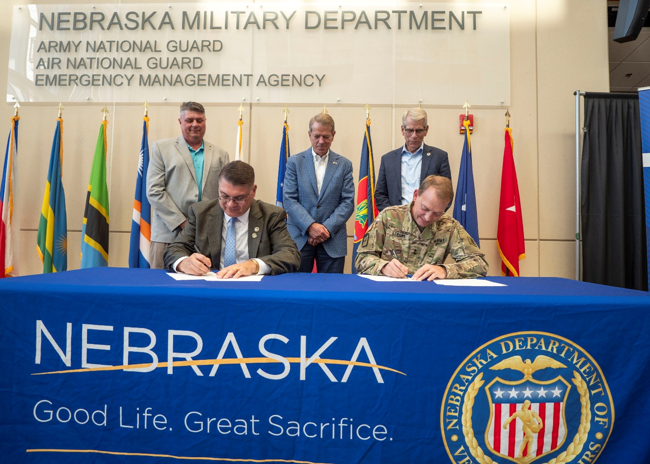
NDVA Director John Hilgert and Nebraska National Guard Adjutant General MG Craig Strong sign an MOU to establish a state veterans service office at Joint Force Headquarters in Lincoln as State Veterans Service Officer Dan Benes, Governor Jim Pillen, and Lieutenant Governor Joe Kelly watch. Additional photos can be found here.
(LINCOLN, Neb.) — Today, Governor Jim Pillen and Lieutenant Governor Joe Kelly joined Nebraska Department of Veterans’ Affairs (NDVA) Director John Hilgert and Nebraska National Guard (NENG) Adjutant General MG Craig Strong as they signed a memorandum of understanding (MOU) to establish a state veterans service officer (SVSO) at NENG Joint Force Headquarters (JFHQ) in Lincoln.
“This is exactly the type of commonsense initiative we want to be undertaking in our state agencies,” said Gov. Pillen. “Not only are we breaking down silos between state agencies, but we’re doing a better job serving our military service members as they leave the service and start their civilian lives in Nebraska.”

The SVSO housed at JFHQ will assist soldiers and airmen separating from the NENG, as well as other veterans, in applying for veterans benefits for which they are eligible. This VA-accredited service officer will assist discharging service members with reviewing service records and determining benefit eligibility for them as well as spouses and dependents, assisting with the accurate completion of forms, transmitting completed claims to the proper state or federal officials, assisting and managing both initial appeals and appeals to the Board of Veterans Affairs, and advising applicants with claims before the U.S. Department of Veterans' Affairs (VA).
“This is an incredibly important step because many of our Veterans often come here to our Joint Force Headquarters when they are updating their records or getting an updated Military ID card,” said Maj. Gen. Strong. “Now, along with these important services, these same Veterans will be able to speak with a trained Veterans Service Officer and ask questions about their eligibility for Veterans services and benefits or receive assistance in what can often be a very complicated or confusing application process.”
“I think this is a capability that is going to make a significant impact in the lives of those who stepped up and served our state and nation,” Strong added.
Nebraska consistently ranks among the nation’s leaders in the percentage of veterans receiving service-connected benefits per capita as well as enrollment in Veterans Healthcare Administration (VHA). In fiscal year 2026, more than $1.6 billion in VA compensation benefits were paid to Nebraska veterans and their family members. SVSOs, County Veterans Service Officers (CVSOs), and Veteran Service Organization Post Officers assist thousands of veterans and family members in Nebraska every year at no cost.

“Governor Pillen has allowed us to expand the number of SVSOs we have around the state, and the results have been tremendous,” said NDVA Director John Hilgert. “Our VA-accredited service officers are experts on veteran benefits, claims, and services, and we look forward to bringing that expertise to Joint Force Headquarters to ensure our National Guard members are equipped for success as they leave the service. I encourage any veteran, spouse, dependent, or surviving spouse to reach out to our team and take advantage of these free services.”

“Veterans who are close to getting out of the Guard and those who already are, will now have a single spot to come, a single spot to check in, and learn about their benefits,” said Lieutenant Governor Joe Kelly. “That’s the goal of all of us, from Governor Pillen down -- is to treat our veterans and our Guard members as very special people, because you are.”

The Nebraska National Guard is a unique component of the U.S. military with a dual state and federal mission. Consisting of the Nebraska Army and Air National Guard, the organization is responsible for providing trained and equipped units ready to respond in the event of a national or state emergency at the order of the President of the United States or the Governor of Nebraska.

NDVA’s mission is to honor Nebraska veterans and their families by providing excellent service, assistance, and care. Its state service office helps veterans identify and access federal benefits, such as disability compensation and healthcare through the U.S. Department of Veterans Affairs, and state benefits, such as Nebraska Veterans Aid, tuition waivers, and more. Its four state veterans’ homes offer high-quality assisted living and skilled nursing care to veterans and eligible family members across the state. And its cemetery system ensures eligible veterans receive an honorable final resting place maintained to the highest national standards. To learn more about NDVA and how it serves Nebraska’s veterans and their families, please visit veterans.nebraska.gov.

###

