FOR IMMEDIATE RELEASE
JULY 24, 2026
Contact:
Laura Strimple, (402) 580-9495
Holden Armstrong, NDVA, (402) 219-1704, holden.armstrong@nebraska.gov

82 Korean War Veterans Recognized in State of Nebraska Ceremony
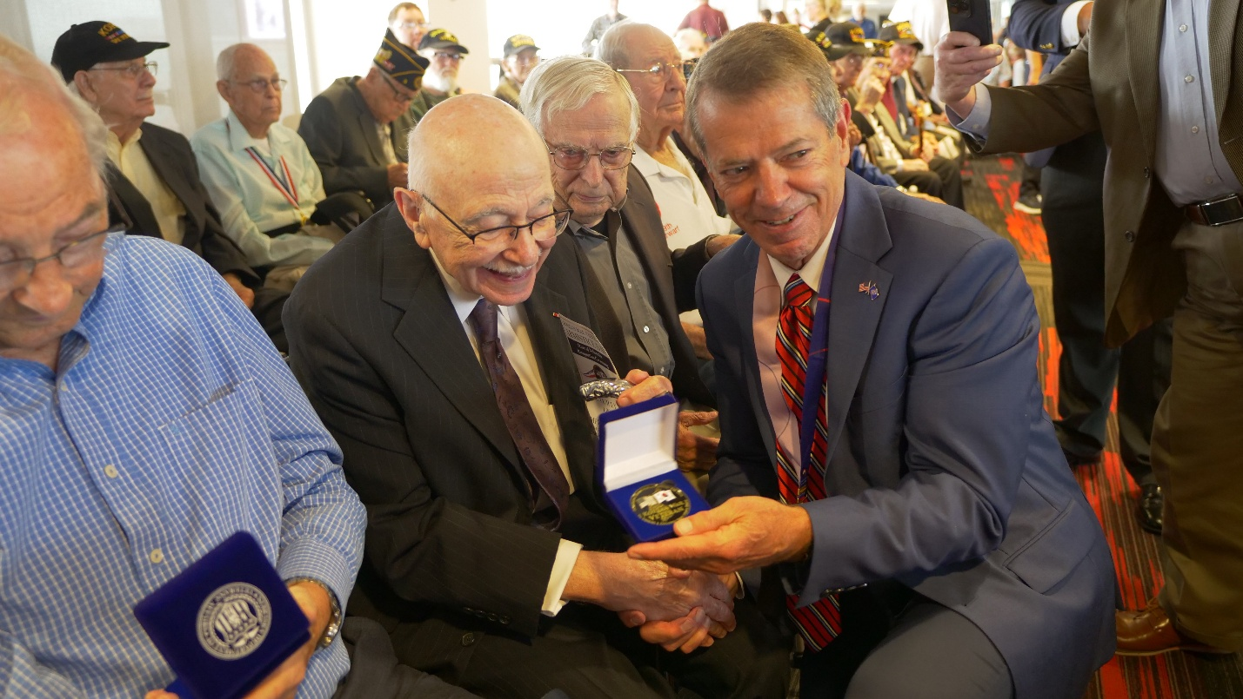Gov. Pillen presenting State of Nebraska recognition coins to veterans in attendance of the ceremony.
LINCOLN, NEB. — Today, Governor Jim Pillen, Nebraska Department of Veterans’ Affairs (NDVA) Director John Hilgert, and Consul General of the Republic of Korea in Chicago Sangwoo Hong recognized 82 of Nebraska’s living Korean War veterans in a ceremony at Memorial Stadium. In total, over 500 people attended the ceremony.
“This recognition program does two very important things,” said Gov. Pillen. “One, we want to give our Korean War veterans a huge ‘thank you’ from the people of Nebraska and let them know we recognize the sacrifices they and their family made. And two, we want to do our part to keep these veterans’ stories alive. As we celebrate our nation’s 250th birthday this year, remembering the men and women who fought to keep our country free is as important as ever so we can enjoy another 250 years and beyond.”
The ceremony was part of an initiative launched earlier this year by Governor Pillen and NDVA to honor Nebraska’s living Korean War veterans. After today’s ceremony, over 250 veterans have received the state’s recognition coin. Veterans can still apply to receive a recognition coin, and community events are scheduled around the state. Information on the program and a listing of currently planned events is available at veterans.nebraska.gov/korea.
“Today’s ceremony was a reminder to our Korean War veterans, and all Nebraska veterans, that the people of Nebraska recognize and honor your service and sacrifices,” said NDVA Director Hilgert. “The turnout for today’s ceremony and the support of this initiative has been incredible. Honoring our veterans is only one piece of NDVA’s mission to support, serve, and advocate for our state’s veterans and their families, but events like this are a reminder of how important it is to recognize our American heroes.”
The ceremony included remarks from Governor Pillen, NDVA Director Hilgert, and Consul General Hong before a presentation of recognition coins to each Korean War veteran in attendance. The Nebraska Korean Association Choir performed renditions of the national anthem of the Republic of Korea, “Aegukga”, and choir vocalist Joyeon Lee sang “The Star-Spangled Banner”. At the conclusion of the ceremony, the choir performed the 600-year-old Korean folk song “Arirang".
“Above all, I would like to convey the deepest respect and heartfelt gratitude of the Government and the people of the Republic of Korea to the Korean War veterans from Nebraska and their families,” said Korean Consul General Sangwoo Hong. “The Republic of Korea will never forget your courage and sacrifice. We will continue to honor your legacy by strengthening our alliance, deepening our partnership with Nebraska, and working together to build a future of greater peace, and prosperity.
Nearly 1.8 million Americans served in the Korean War, which resulted in over 36,000 U.S. casualties, including 318 Nebraskans. According to the Defense POW/MIA Accounting Agency, 7,359 American soldiers remain unaccounted for, including 56 from Nebraska. Of the Nebraskans who came home from the war, an estimated 2,400 are still living in the state.
NDVA’s mission is to honor Nebraska veterans and their families by providing excellent service, assistance, and care. Its state service office helps veterans identify and access federal benefits, such as disability compensation and healthcare through the U.S. Department of Veterans Affairs, and state benefits, such as Nebraska Veterans Aid, tuition waivers, and more. Its four state veterans’ homes offer high quality assisted living and skilled nursing care to veterans and eligible family members across the state. And its cemetery system ensures eligible veterans receive an honorable final resting place maintained to the highest national standards. To learn more about NDVA and how it serves Nebraska’s veterans and their families, please visit veterans.nebraska.gov.
###
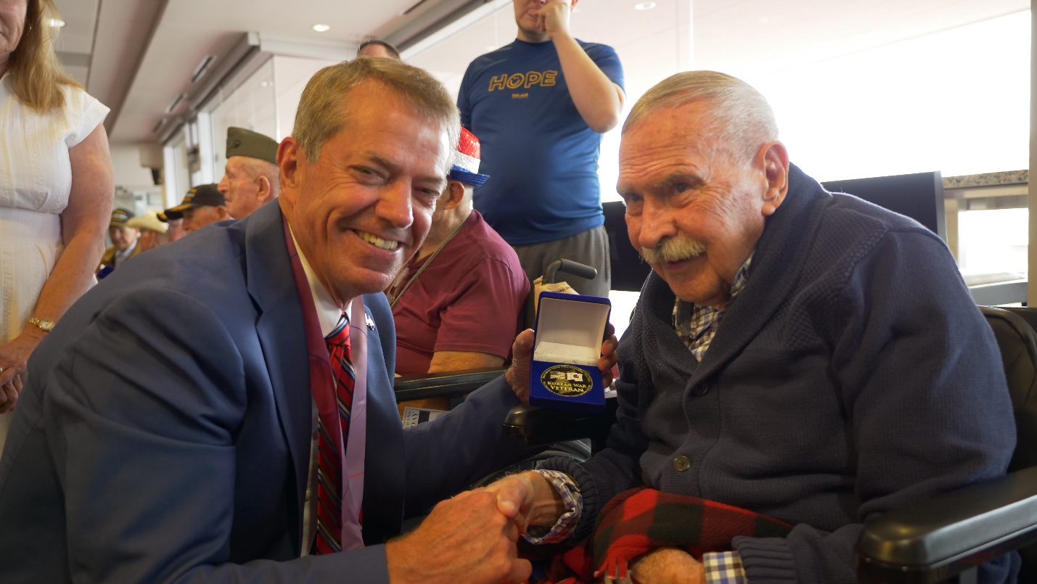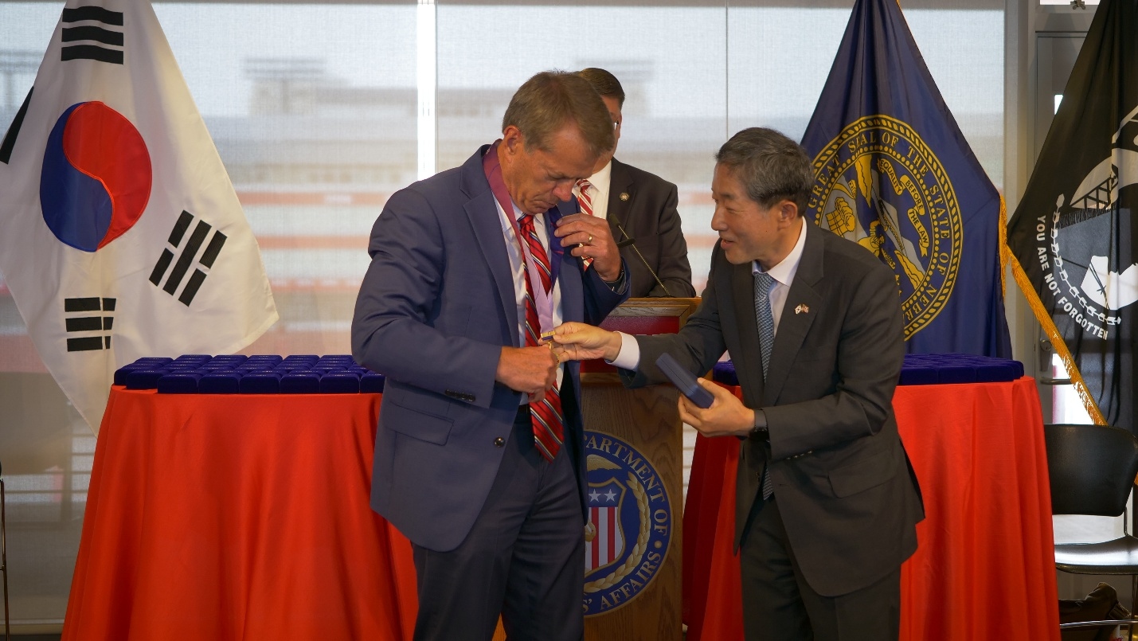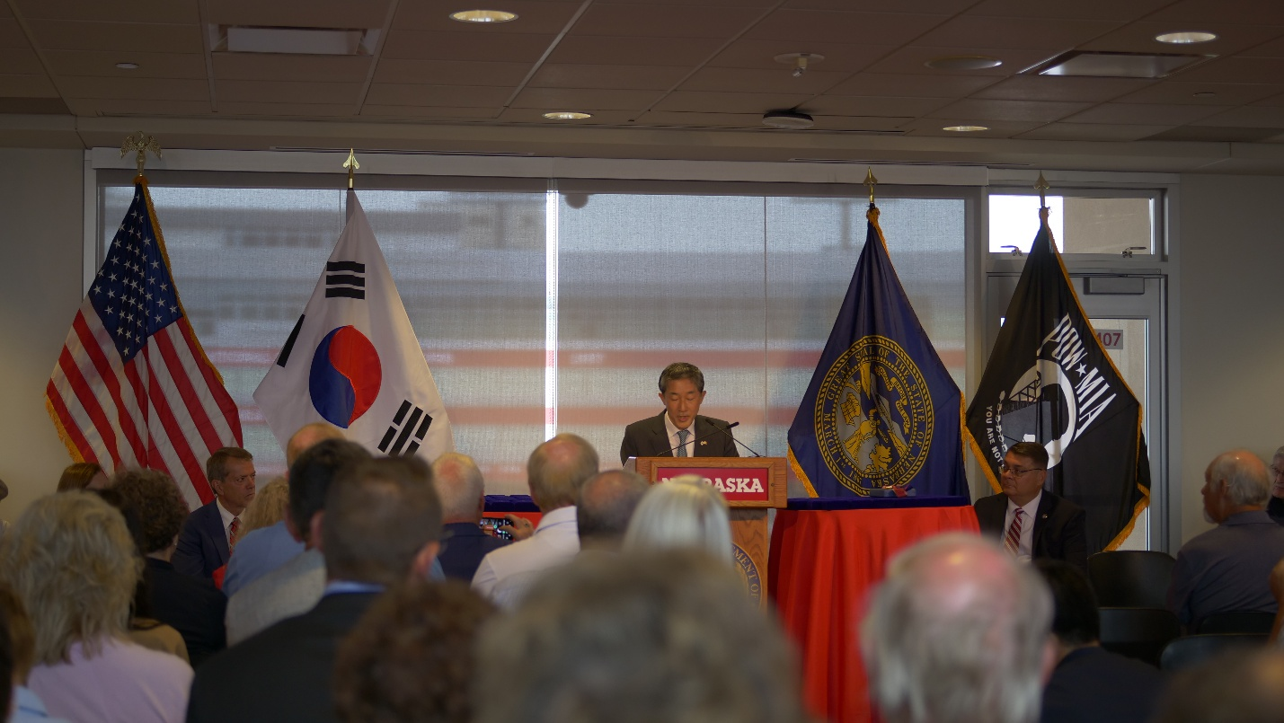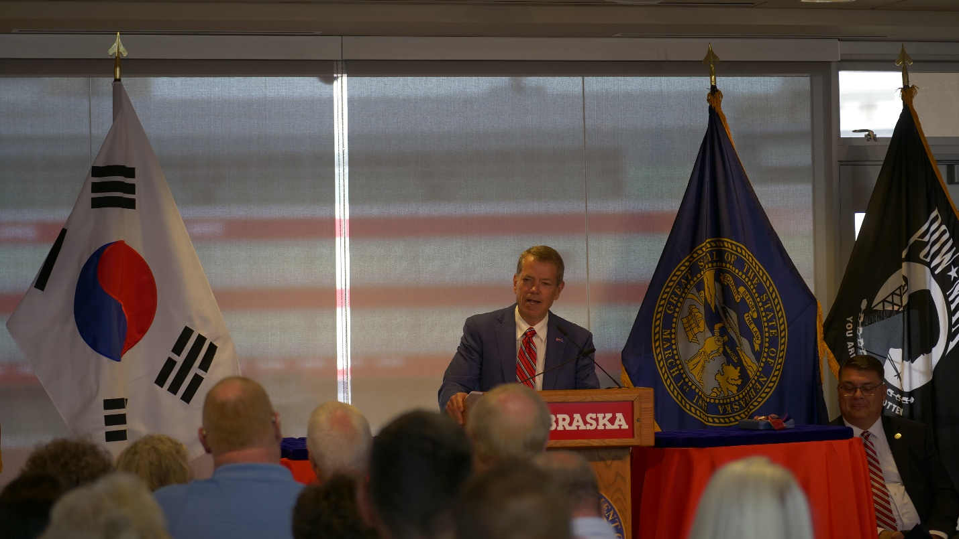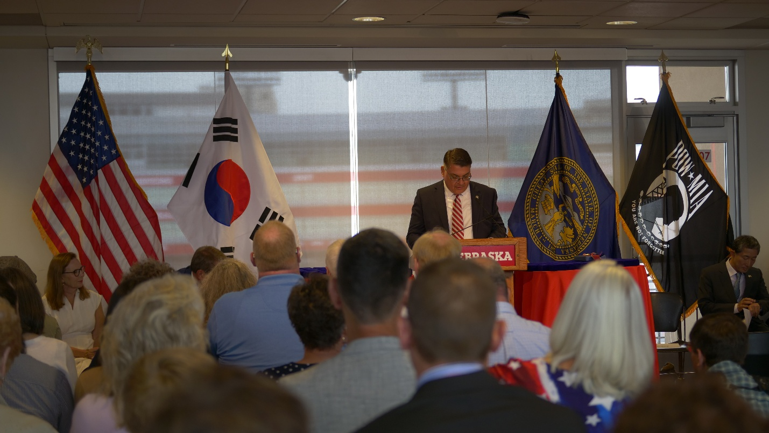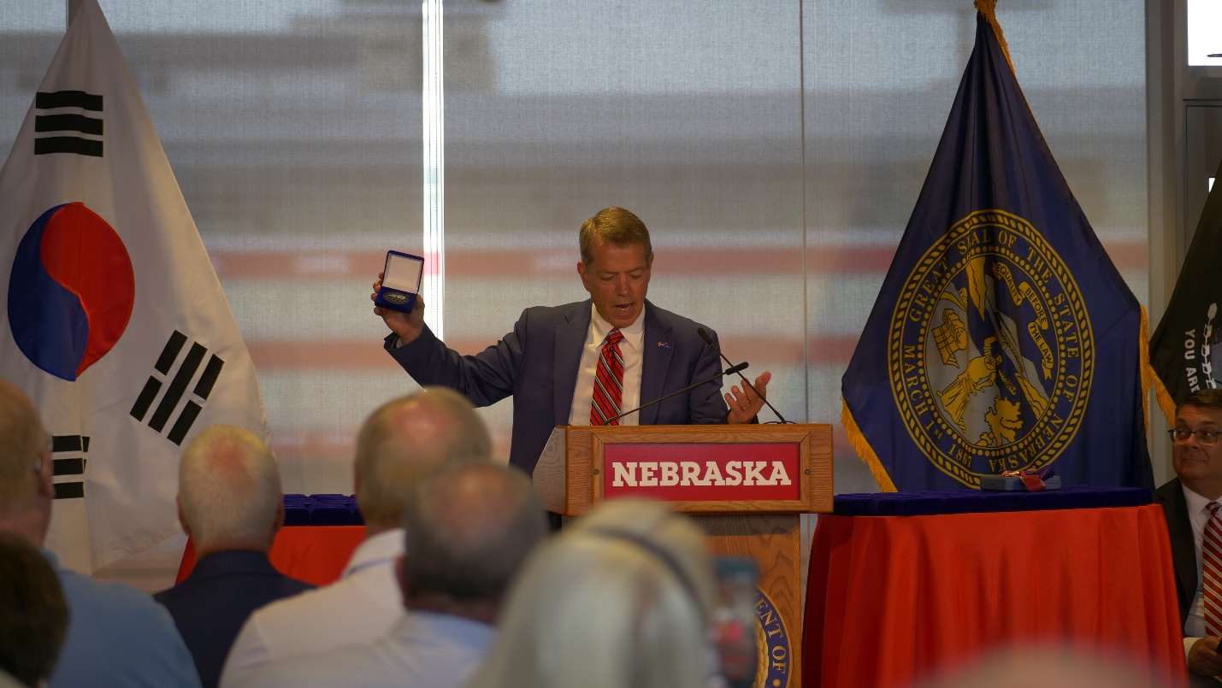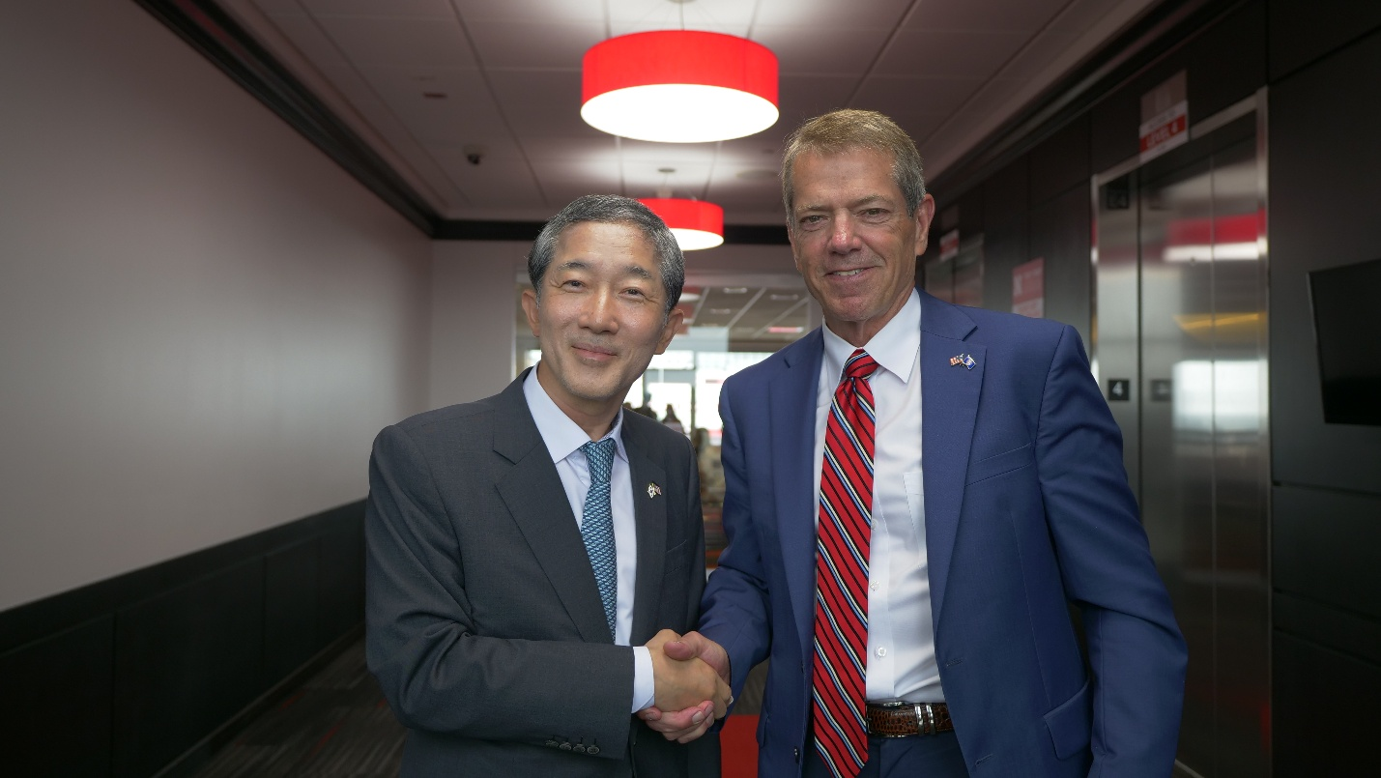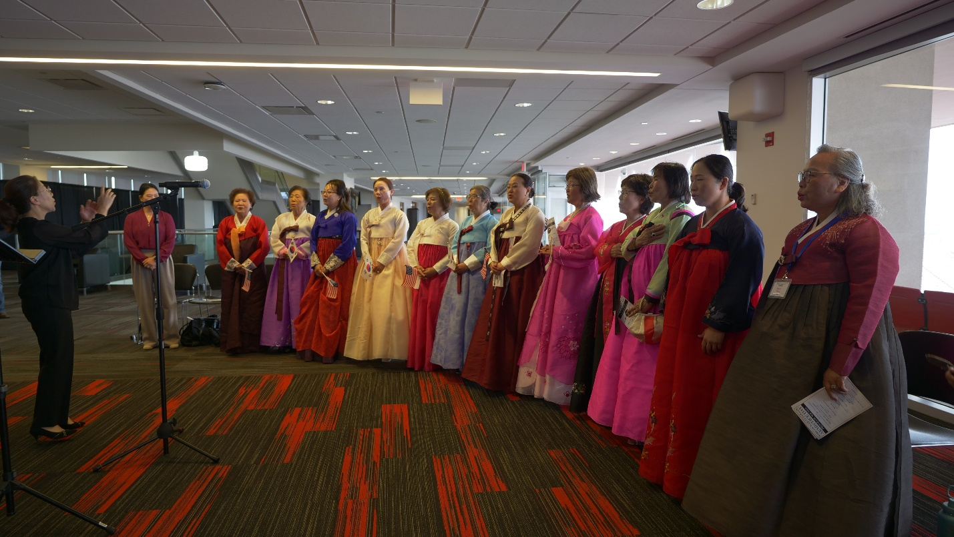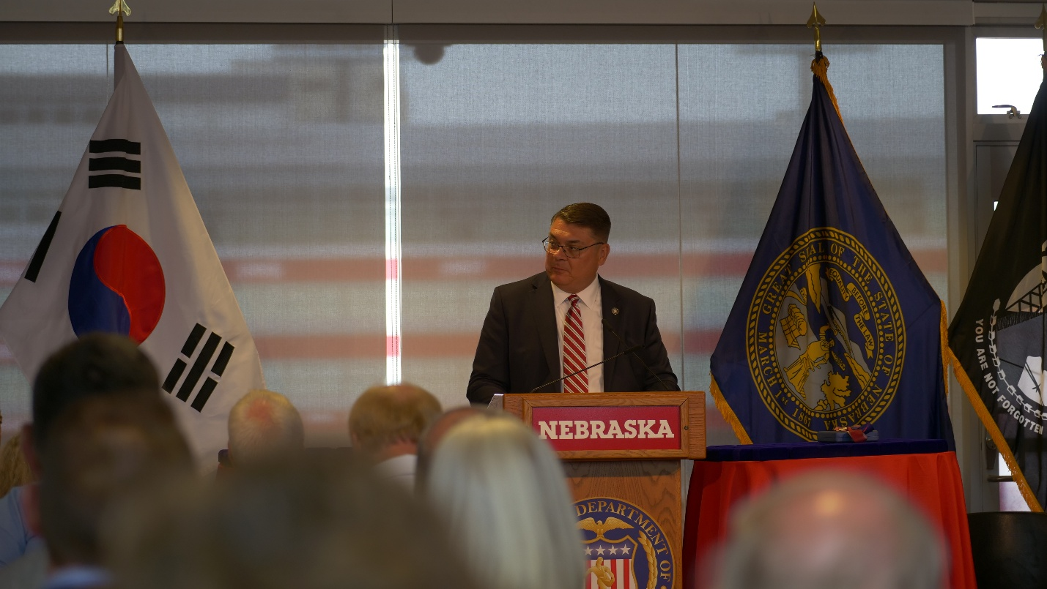

List of recipients at today’s ceremony:
First Name | Last Name | City
Harold | Miller | Albion
Clinton | Olmsted | Arapahoe
Erling | Place | Arlington
Paul | Kruse | Auburn
Ray | Boevink | Beatrice
Kenneth | Britenstine | Bellevue
Donald | Fry | Bellevue
Ralph | Steward | Bennett
Charles | Sheets | Bennington
Donald | Lubben | Bruning
Frederick | Benesch | Bruno
Earl | Sedlacek | Bruno
James | House | Cheyenne
Anton | Grohman | Columbus
Orville | Schmidt | Cozad
Gerald | Maresh | Dodge
Larry | Polich | Elkhorn
Robert | Kotas | Fairberry
Junior | Prange | Firth
Charles | Zoubek | Firth
Eddie | Falton | Fremont
Arnold | Lessig | Fremont
Richard | Hoover | Grand Island
Donald | Jansen | Ithaca
Harry | Klimek | Kearney
Curtis | Sanford | Linclon
LeRoy | Andresen | Lincoln
Henry | Bienhoff | Lincoln
Robert | Buckner | Lincoln
John | Campbell | Lincoln
Robert | Cardwell | Lincoln
Marion | Charron | Lincoln
Peter | Gandara | Lincoln
John | Hegel | Lincoln
Robert | Houser | Lincoln
James | Johnson | Lincoln
Garold | Kleveland | Lincoln
Dennis | Kliment | Lincoln
Ven | Lanik | Lincoln
Max | Marquart | Lincoln
Bernard | Michael | Lincoln
Richard | Nelson | Lincoln
Gene | Norton | Lincoln
Donald | Osentowski | Lincoln
William | Pederson | Lincoln
Leonard | Ratzlaff | Lincoln
Gerald | Riggins | Lincoln
Kenneth | Schneider | Lincoln
Lyle | Stoner | Lincoln
Donald | Weber | Lincoln
Frederick | Welch | Lincoln
Charles | Wilson | Lincoln
Lambert | Zoubek | Lincoln
Leonard | Bradford | Lorton
Robert | Johnson | North Bend
Charles | Andrews | Omaha
Frank | Beckman | Omaha
Nick | Caporale | Omaha
Charles | Gruber | Omaha
Robert | Hutton | Omaha
Raymond | Kempnich | Omaha
Jeannette | Kuehn | Omaha
Myron | Marko | Omaha
John | Morris | Omaha
Ronald | Pilege | Omaha
Ralph | Quosig | Omaha
Gerald | Roslawski | Omaha
Ronald | Simmons | Omaha
William | Wegener | Omaha
Warren | Williamson | Omaha
Robert | Moore | Papillion
Paul | Schettler | Papillion
Ralph | Holzfaster | Paxton
Alphonse | Polacek | Prague
Tony | Miranda | Roca
Carl | Hinds | Sioux City
Richard | Leitchuck | Sioux City
Darrell | Jensen | Superior
William | Preuit | Waco
Lloyd | Olmsted | Waterloo
Clarence | Althouse | Waverly
Richard | Christian | York

