FOR IMMEDIATE RELEASE
JULY 13, 2026
Contact:
Holden Armstrong, Communications Director
(402) 219-1704, holden.armstrong@nebraska.gov
National Cemetery Administration Presents Stewardship Award to Nebraska Veterans Cemetery at Alliance
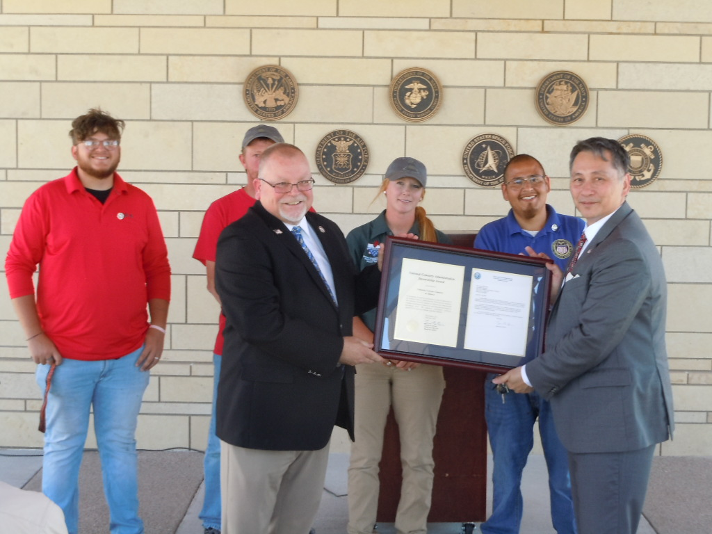
Veterans Cemetery Grants Program Director James Earp (front right) presents the NCA Stewardship Award to Cemetery Manager James Goodwin. Behind them are (from left to right) NVCA public servants Peyton Hornung, Danny Blow, Alisha Coffee, and Jacob Hernandez.
(ALLIANCE, NEB.) — On July 9, James Earp, director of the National Cemetery Administration (NCA) Veterans Cemetery Grants Program, presented NCA’s Stewardship award to Nebraska Veterans Cemetery at Alliance (NVCA) Manager James Goodwin.
“Under the leadership of Director Jim Goodwin, the team at the Nebraska State Veterans Cemetery at Alliance earned NCA’s Stewardship Award for their outstanding scores during NCA’s compliance review,” said Earp. “Throughout these hallowed grounds, everywhere you look you can see their commitment to excellence, meticulous care, and unwavering dedication to honoring Veterans and their families. Their professionalism and compassion define the highest ideals of service.”
The award recognizes superior cemetery performance based on the results of an NCA-led compliance review of Veterans Affairs (VA) grant-funded state, territory, and tribal veteran cemeteries. NVCA’s compliance review was held in July 2025.
“I want to commend our team in Alliance for the work they do every day to ensure our veterans and their families are ensured a final resting place of honor and dignity,” said NDVA Director John Hilgert. “NVCA has consistently been recognized as a high performer nationally, and this recognition is one of many for the incredible work Jim and his team do.”
Nebraska has two state veterans cemeteries—located in Alliance and Grand Island—that are run by NDVA. It also has two national cemeteries – the Omaha National Cemetery and the Fort McPherson National Cemetery in Maxwell. Both are operated by the U.S. Department of Veterans Affairs. For more information on the Nebraska Department of Veterans’ Affairs and the services it offers, visit veterans.nebraska.gov.

###

Additional photos: remarks from Cemetery Manager James Goodwin, NCA Veterans Grants Program Director James Earp, and NDVA Deputy Director Levi Bennett.
