FOR IMMEDIATE RELEASE
April 27, 2026
Contact:
Laura Strimple, (402) 580-9495
Holden Armstrong, NDVA, (402) 219-1704
Gov. Pillen, NDVA Announce Korean War Veteran Recognition Program
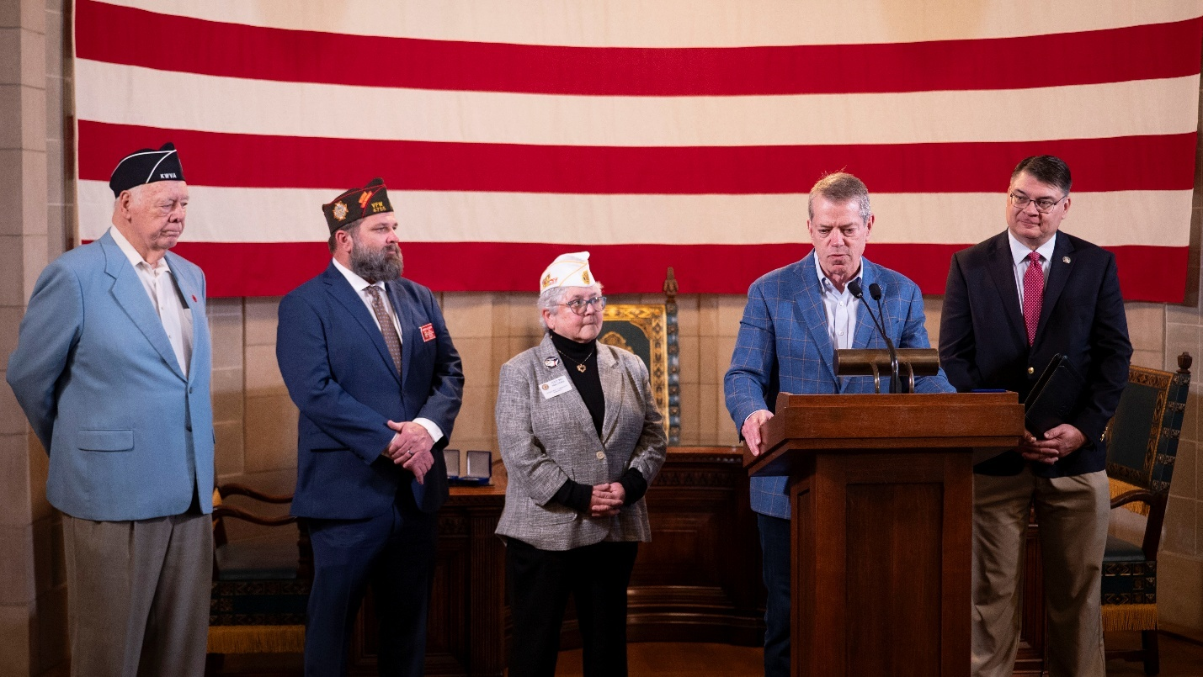
Gov. Pillen announces the State of Nebraska’s Korean War veteran recognition initiative. Behind him, from left to right, are Korean War Veterans Association Nebraska Chapter President Dan Ryberg, VFW Department of Nebraska Adjutant Jeffrey Baker, American Legion Department of Nebraska Commander Judy Walters, and NDVA Director John Hilgert. More photos of the announcement and the challenge coins are available here.
LINCOLN, NEB. — On Monday, Governor Jim Pillen and Nebraska Department of Veterans’ Affairs (NDVA) Director John Hilgert announced a state initiative to recognize Nebraska’s living Korean War veterans with a specially minted challenge coin. Joining for the announcement were American Legion Department of Nebraska Commander Judy Walters, Veterans of Foreign Wars (VFW) Department of Nebraska Adjutant Jeffrey Baker, and Korean War Veterans Association (KWVA) Nebraska Chapter President Dan Ryberg.

“We can never fully repay the men and women who have fought to protect our freedoms and way of life, but we can make sure we thank them and recognize them for their service,” said Gov. Pillen. “Honoring Nebraska’s Korean War veterans is about celebrating them and what they’ve done to safeguard the world. It’s about keeping these stories alive so their children, grandchildren, and great-grandchildren know why we can have the American dream.”

The challenge coin is available to living veterans who served in the U.S. Armed Forces between June 27, 1950, and January 31, 1955; are legal residents of Nebraska or can demonstrate Nebraska residency at the time they entered the service; and discharged under conditions other than dishonorable. The coin comes in a blue velvet presentation case and features the 48-star U.S. flag from the period and the flag of South Korea above the words “Korean War Veteran”. Along the outside of the coin it says, “Honoring those who answered the call to defend a country they never knew” and on the back is the NDVA seal.

“Part of NDVA’s mission is to recognize and honor Nebraska’s veterans and their families,” said NDVA Director John Hilgert. “We want to connect with our state’s Korean War veterans to thank them for their service, let them know Nebraskans appreciate what they did, and at the same time ensure they’re receiving all the benefits they’ve rightly earned.”

The state will be hosting a ceremony to recognize Korean War veterans and present challenge coins in person at the Nebraska State Capitol on July 24, 2026. Details on the event and the required RSVP are available at veterans.nebraska.gov/korea. In addition to the state’s in-person event, NDVA is partnering with veterans service organizations, counties, and others to help distribute the challenge coins to the state’s estimated 2,400 living Korean War veterans. Representatives from the American Legion and VFW joined for the announcement to discuss distributing challenge coins to members at their posts around the state, at their conventions, and at other events.

“Veterans of Foreign Wars is excited to be able to get out into the communities and show that we are still supporting veterans every day, and we look forward to being a partner to NDVA to accomplish that mission,” said VFW Department of Nebraska Adjutant Jeffrey Baker. “In addition, we will work with the American Legion and the local communities, and we’ll do it together, so we’re very excited about this opportunity.”

“Any time that we can educate and get the stories out there of our wartime veterans, it’s a special time,” said American Legion Department of Nebraska Commander Judy Walters. “With the 250th [anniversary of America], there’s going to be so many events across the state and we’re going to have so many opportunities to get out and let people know what the Korean War was about and what these veterans did for our country.”

KWVA Nebraska Chapter President Dan Ryberg was also in attendance at the announcement to speak on behalf of the association. “I would charge every high school history teacher to not let their class graduate unless they know at least two terms: Yalu River and Chosin Reservoir,” said Ryberg. “If they can walk away from your class with those four words, then they will remember a bit of history that is well worth knowing.”

More details on the challenge coin and the initiative are available at veterans.nebraska.gov/korea.

NDVA’s mission is to honor Nebraska veterans and their families by providing excellent service, assistance, and care. Its state service office helps veterans identify and access federal benefits, such as disability compensation and healthcare through the U.S. Department of Veterans Affairs, and state benefits, such as Nebraska Veterans Aid funds, tuition waivers, and more. Its four state veterans’ homes offer high quality assisted living and skilled nursing care to veterans and eligible family members across the state. And its cemetery system ensures eligible veterans receive an honorable final resting place maintained to the highest national standards. To learn more about NDVA and how it serves Nebraska’s veterans and their families, please visit veterans.nebraska.gov.
###

