FOR IMMEDIATE RELEASE
March 27, 2026
Contact:
Laura Strimple, Governor’s Office, (402) 580-9495
Holden Armstrong, Dept. of Veterans’ Affairs, (402) 219-1704

Vietnam War Veterans Recognized at State Capitol Ceremony
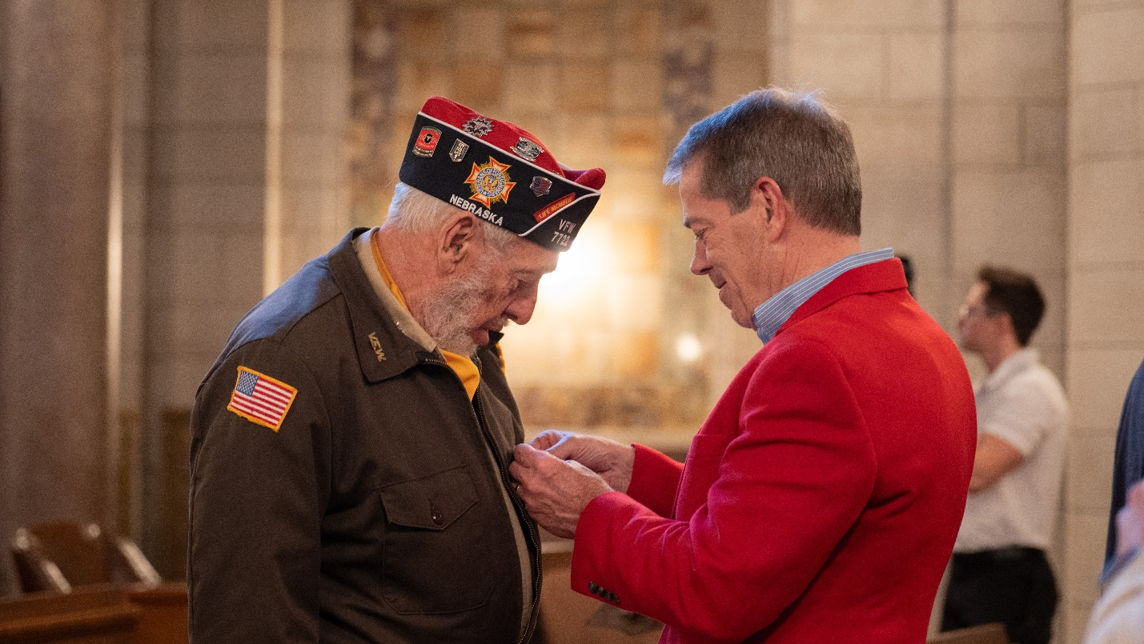
Gov. Pillen pins a Vietnam War lapel pin on a veterans’ jacket at the State of Nebraska’s Vietnam War Veterans Day ceremony. More photos from the event are available by clicking here.
LINCOLN, NE – Today, Governor Jim Pillen, Nebraska Department of Veterans’ Affairs (NDVA) Director John Hilgert, and Nebraska National Guard Adjutant General MG Craig Strong honored Vietnam War period veterans at Nebraska’s annual Vietnam War Veterans Day ceremony.
“Nebraskans are proud of our veterans and military families,” said Gov. Pillen. “Today is about coming together to thank and recognize the soldiers who served in Vietnam, many of whom did not receive thanks when they initially came back from the war. To all the Vietnam veterans of Nebraska, we honor your service and are here to support you as friends, neighbors, and family.”
During the ceremony, Governor Pillen signed a proclamation declaring March 29 “Vietnam War Veterans Day” in the state of Nebraska. Nationally, March 29 has been recognized as Vietnam War Veterans Day since 2017.
“Nebraska continues to recognize and serve our Vietnam veterans with this meaningful and important ceremony,” said NDVA Director John Hilgert. “There are lessons to be learned from the past and today is a reminder to thank and welcome home all our nation’s heroes, wherever and however they’ve served. They donned the cloth of our country to protect our citizens and allies around the world, putting themselves at risk for something greater, and we cannot ever forget that.”
Over 75 people attended the ceremony, including 30 Vietnam veterans, family members, friends, and fellow veterans. Around 64,000 Nebraskans served during the Vietnam War, and the state is currently home to around 32,000 Vietnam-era veterans according to data from the U.S. Department of Veterans Affairs National Center for Veterans Analysis and Statistics. Events are being held throughout the state—including at the four state veterans’ homes—to honor and recognize them for their service this week.
“We, as a grateful nation, can never forget the incredible debt that we owe our American Veterans and their families who, through their tremendous service and sacrifices, have given so much in defense of our country,” said Nebraska Adjutant General Major General Craig Strong. “That is especially the case with our Vietnam Veterans who did not receive the thanks and gratitude that they so richly deserved. Friday’s ceremony is our chance to continue to give these amazing Americans a belated thank you for your service and welcome home.”
NDVA’s mission is to honor Nebraska veterans and their families by providing excellent service, assistance, and care. Its state service office helps veterans identify and access federal benefits, such as disability compensation and healthcare through the U.S. Department of Veterans Affairs, and state benefits, such as Nebraska Veterans Aid, tuition waivers, and more. Its four state veterans’ homes offer high quality assisted living and skilled nursing care to veterans and eligible family members across the state. And its cemetery system ensures eligible veterans receive an honorable final resting place maintained to the highest national standards. To learn more about NDVA and how it serves Nebraska’s veterans and their families, please visit veterans.nebraska.gov.
###

