FOR IMMEDIATE RELEASE
SEPTEMBER 29, 2026
Contact:
Holden Armstrong, NDVA Communications Director
(402) 219-1704, holden.armstrong@nebraska.gov
Veterans Mission of Mercy Dental Event Provides Over $600k in Free Dental Care to Hundreds of Veterans, Spouses
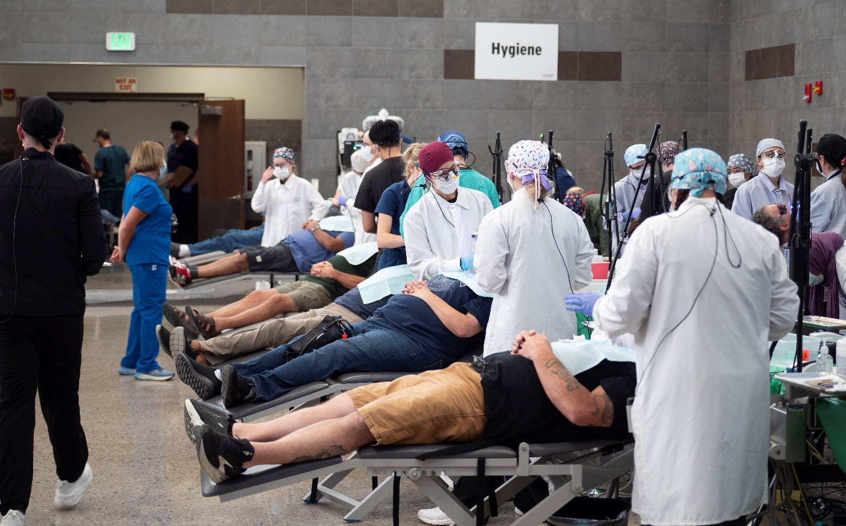Hundreds of patients passed through the two-day VETMOM dental event and received free dental care at the Nebraska National Guard Titan Readiness Center. Additional photos can be found here.
(NEB.) — The 2026 Veterans Mission of Mercy (VETMOM) dental event, held August 28 and 29 at the Nebraska National Guard Titan Readiness Center near Yutan, provided $611,850 worth of free dental care to veterans, spouses, and surviving spouses of deceased veterans, based on average dental care rates in Nebraska. Over the two-day event, 2,817 dental services, ranging from exams and x-rays to cleanings and extractions, were performed in 452 patient visits, including 152 denture services. VETMOM’s four-year total now exceeds 10,800 dental services provided in over 1,700 patient visits with a total value of over $2.24 million based on average dental care rates in Nebraska.
“VETMOM is a prime example of how Nebraskans come together to take care of their fellow Nebraskans,” said NDVA Director John Hilgert. “This event is not the result of a specific state or federal program or a legislative bill. No one compelled any department, agency, group, or provider to participate and support this effort. VETMOM is the result of people freely giving what they can to address a need in the community, in this case, the veteran community.”
“It is such an honor to care for our veterans and give them the health services they deserve,” said State Dental Health Director Dr. Charles F. Craft. “They are always grateful, and the providers are also enriched by these special professional experiences. This unique military-civilian collaboration has pooled together our individual resources and formed a result that is much greater than our individual parts.”
In a post-event survey, 99.4% of respondents indicated they were satisfied or very satisfied with the care they received, with 100% of respondents indicating they would recommend other veterans attend a future event. The survey also showed close to 60% of respondents do not have a regular dentist and over 20% had not had a dental procedure other than a cleaning in over five years, further highlighting the need for these services. Nearly 25% of survey respondents indicated they traveled over 100 miles to attend the event, with 9.5% traveling over 250 miles.
Army veteran Kenneth Blum traveled to the event from Schuyler for partial dentures. “It was a great experience, and everybody was more than helpful,” he said. “They were truly concerned about each veteran’s different needs and genuinely caring. The service was awesome.”
Around 12-15% of veterans are eligible for dental care through the U.S. Department of Veterans Affairs (VA), and dental care is one of the top expenses for veterans utilizing Nebraska Veterans’ Aid (NVA), which provides temporary financial assistance to veterans, spouses, and dependents facing financial emergencies. In fiscal year 2026, dental care accounted for over $287,000 of NVA funds disbursed, which is about 12% of the total NVA funds distributed in that period.
"Oral health isn't separate from overall health, it's foundational to it. Untreated dental disease can affect nutrition, cardiovascular health, and a person's confidence to work and engage with their community,” said UNMC College of Dentistry Executive Associate Dean Dr. Gregory Bennett. “Getting to play a small part in giving that back to the veterans who served us is one of the most meaningful things I get to do all year.”
VETMOM is made possible through partnerships between the Nebraska Department of Veterans’ Affairs, Nebraska Army National Guard, DHHS Office of Oral Health, Nebraska Dental Foundation, UNMC College of Dentistry, Creighton School of Dentistry, Nebraska Dental Hygienists’ Association and companies such as Dental Designs, Patterson Dental, and Dexis Imagining.
Over 400 volunteers, including dental school faculty, dental and dental hygiene students, dental assistants, U.S. Air Force 55th Dental Squadron personnel, and private dentists from around the state donated their time and experience to provide care at the event. This year’s VETMOM included volunteer dentists from as far away as Alaska and Thailand. Numerous non-dental volunteers, including members of local American Legion and VFW posts, helped with the clinical setup, check-in, escorting patients, and other non-clinical tasks.
The event is funded through private donations to the Nebraska Dental Foundation. Major financial supporters of the 2026 VETMOM include Hornady, Ameritas, and Google Nebraska. The equipment is secured through the America’s Dentists Care Foundation.
“VETMOM is a great example of what can happen when so many organizations and individuals come together around a shared purpose,” said Lisa Sypal, executive director of the Nebraska Dental Association and the Nebraska Dental Foundation. “From our state agencies and military partners to the dental schools, dental professionals, industry partners, donors and hundreds of volunteers, everyone brings something different to the effort. It truly takes all of those pieces working together to make an event of this size possible and provide this level of care to Nebraska’s veterans and their families.”
After their appointment, patients were able to meet with accredited veterans service officers from the state and county who could assist in learning about benefits and services, filing or checking claims, and more. Outreach teams from VA’s Veterans Health Administration, Veterans Benefits Administration, and Vet Center were on hand to offer additional resources to attendees. The Hanes Mobile Military Museum was on display with uniforms from the U.S. Armed Forces branches throughout the years, including a special exhibit of historical medical uniforms from several military branches.
Veterans, spouses, or surviving spouses who want to stay informed on the next VETMOM planned for the fall of 2027, as well as other veteran events, resources, benefits, and services, can sign up to receive NDVA email updates at veterans.nebraska.gov/newsletter.
NDVA’s mission is to honor Nebraska veterans and their families by providing excellent service, assistance, and care. Its state service office helps veterans identify and access federal benefits, such as disability compensation and healthcare through the VA, and state benefits, such as Nebraska Veterans Aid funds, tuition waivers, and more. Its four state veterans’ homes offer high-quality assisted living and skilled nursing care to veterans and eligible family members across the state. And its cemetery system ensures eligible veterans receive an honorable final resting place maintained to the highest national standards. To learn more about NDVA and how it serves Nebraska’s veterans and their families, please visit veterans.nebraska.gov.
###
Please note: this press release has been updated with more accurate numbers since the initial release was sent.
