FOR IMMEDIATE RELEASE
DECEMBER 2, 2025
Contact:
Holden Armstrong - NDVA
(402) 219-1704, holden.armstrong@nebraska.gov
Betty Johnson - DMV
(402) 471-3909, betty.johnson@nebraska.gov
Disabled Veteran Motor Vehicle Tax, Fee Exemption Goes into Effect Jan. 1
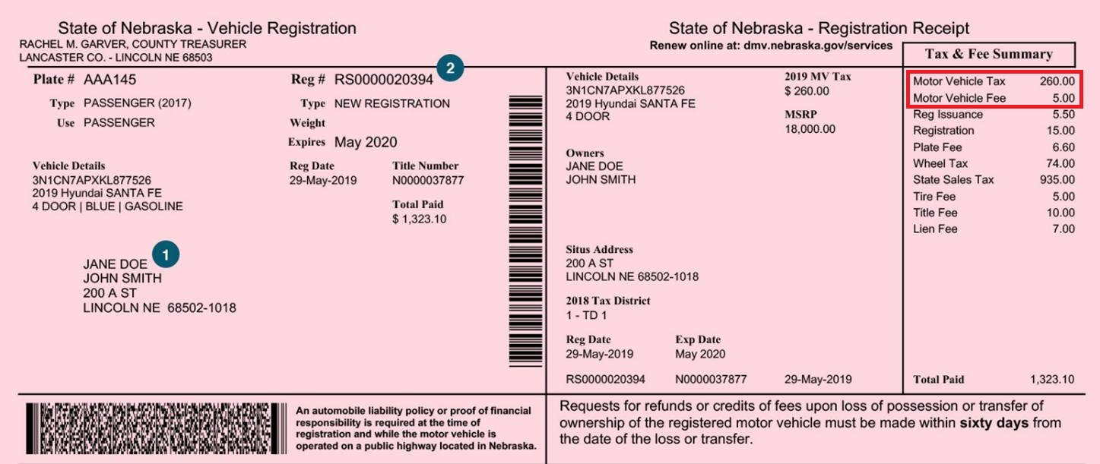Disabled veterans in Nebraska can soon have the Motor Vehicle Tax and Motor Vehicle Fee (outlined in red in the example) exempted from their vehicle registration for one vehicle.
(NEB.) — Starting January 1, 2026, disabled veterans in Nebraska can receive a motor vehicle tax and fee exemption for one vehicle owned and used for their personal transportation. The new exemption is part of LB650, which passed and was signed into law in 2025.
The law provides two definitions of a “disabled veteran”, which are:
- an individual who served on active duty in the armed forces, has separated under honorable conditions, and has established the present existence of a service-connected disability (including those rated at 0%); or

- an individual who is receiving compensation, disability retirement benefits, or pension because of a public statute administered by the U.S. Department of Veterans Affairs (VA) or a military department.
Veterans must apply to the Nebraska Department of Veterans’ Affairs (NDVA) Military & Veterans’ Registry, which can be found at veterans.nebraska.gov/registry, so their eligibility can be verified. Qualifying veterans who are already in the registry will need to have their registry information updated by an NDVA state service officer (402-420-4021 or ndva.sso@nebraska.gov) or their county veterans service officer, whose contact information can be found at veterans.nebraska.gov/cvso.
Veterans are encouraged to apply in advance of their registration or renewal as it may take up to 48 hours for information to be available to the Department of Motor Vehicles (DMV) after a registry application is approved.
When registering or renewing a vehicle in person, a qualifying veteran will need to inform the county treasurer’s staff they qualify for the exemption. When renewing online, they will need to select the “Disabled Veteran Tax Exemption” option on the online application.
The request for the tax exemption must occur within 30 days after purchase of a vehicle. For registration renewal, the request must occur prior to the final day of the expiration month. If the request is made outside the required timeframe, the veteran will not qualify for the exemption until the next renewal period.
Full details on the exemption, eligibility, application process, and more can be found at veterans.nebraska.gov/vehicletax.
###

