FOR IMMEDIATE RELEASE
OCTOBER 10, 2025
Contact:
Holden Armstrong, NDVA Communications Director
(402) 219-1704, holden.armstrong@nebraska.gov
Nebraska Veterans Mission of Mercy Dental Event Provides Free Dental Care to Veterans, Spouses
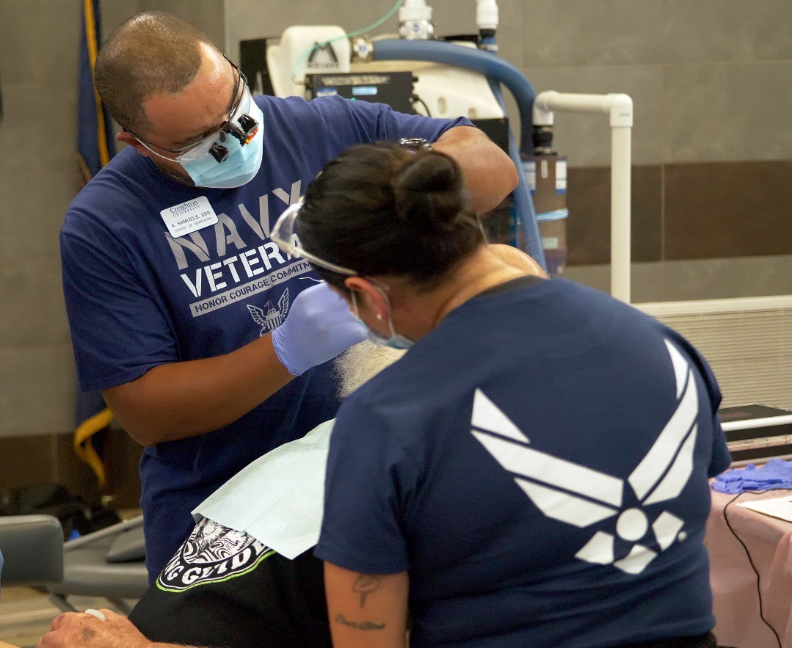
A patient at the 3rd annual Veterans Mission of Mercy Dental Event receives care from Navy and Air Force veterans. Several of the dentists, dental hygienists, and other volunteers at the event were veterans themselves. Additional photos can be found here.
(YUTAN, NEB.) — On September 26 and 27, hundreds of veterans, spouses, and surviving spouses passed through the Nebraska National Guard (NENG) Titan Readiness Center near Yutan to receive free dental care during Nebraska’s third Veterans Mission of Mercy (VETMOM) Dental Event. The free dental care provided was worth $572,245.
“It’s hard to put into words how incredible this dental clinic is,” said Lieutenant Governor Joe Kelly, who toured the site on September 26. “Every room is filled with patients and bustling with activity. There are hundreds of people volunteering their time, sacrificing their weekend, because this is such a worthy cause. Our veterans have served to protect us, and as Nebraskans we are here to repay them.”
Of Nebraska’s 115,000 veterans, only around 10% qualify for dental care through the U.S. Department of Veterans Affairs (VA). Access to dental care is one of the most requested needs reported to the Nebraska Department of Veterans’ Affairs (NDVA), which provided over $300,000 in emergency financial assistance related to dental care through the Nebraska Veterans Aid Fund in fiscal year 2025. The VETMOM seeks to bridge that gap and provide at least some of the dental care needed by Nebraska’s veterans.
“I want to commend everyone involved in the VETMOM, from the partners who helped plan and execute the clinic to the private businesses who volunteered time and materials to the sponsors who covered the cost,” said NDVA Director John Hilgert. “We know there’s a need. We know this is important. And we have an incredible group of Nebraskans who are stepping up to solve the issue. It really is like clockwork at this point, and I’m looking forward to many more years of providing this care.”
Over the course of the event, 2,949 dental services—including cleanings, fillings, root canals, extractions, x-rays, and more—were provided in about 440 patient visits. More than one hundred dentures were provided, as well. Dentists on site took digital impressions and emailed them to Dental Designs, where technicians designed and 3D printed prosthetics for veterans. With a team of roughly 30 technicians, Dental Designs personnel were on site and back in the lab working around the clock to deliver partials and dentures for patients within 24 hours of their first visit.
“Accessing quality dental care services is a huge challenge for many veterans, especially for older people,” said State Dental Health Director Dr. Charles F. Craft. “Much of the dental care provided at the VETMOM event involved the need for dentures to replace missing teeth that are essential for proper eating. The ability to receive dentures quickly within a 48-hour period speaks to the dedication of our many professional volunteers and partner organizations who worked around the clock to give back to our Nebraska veterans.”
The two-day event was a partnership between NDVA, NENG, DHHS Office of Oral Health and Dentistry, Nebraska Dental Association, Nebraska Dental Hygienists’ Association, University of Nebraska Medical Center College of Dentistry, and Creighton University School of Dentistry. It was supported by hundreds of volunteers, including dentists, dental students, dental hygienists, dental hygiene students, and private dental practices. Numerous non-dental volunteers, including members of local American Legion and VFW posts, helped with setup, check-in, and other non-clinical tasks. Sponsors for the event included Hornaday, Dental Designs, Ameritas, Patterson Dental, Dexis Imaging, Google, and Farmers Mutual.
“It was an honor to take care of the dental needs for our veterans,” said Dr. James Jenkins, associate professor at the UNMC College of Dentistry who served as the VETMOM clinical director. “I hope they felt appreciated for their service to our nation to protect the freedoms we all enjoy. It was a true team effort, and all the volunteers worked very hard and did a great job. I know our volunteers were blessed by helping others, as were the patients we treated. It was great to see the new smiles on the faces of many of the veterans we served!”
Each year, NENG has allowed the use of the Titan Readiness Center to host the VETMOM. Not only has the space worked well for the event, but its location has helped ensure volunteers from the state’s two dental schools, located in Lincoln and Omaha, can participate. Its large gym served as the main work area and smaller rooms provided space for triage, radiology, patient recovery, and other clinical needs. Accredited veterans service officers from the state and county were available to assist veterans in learning about benefits, filing or checking claims, and more. Staff from the Veterans Health Administration, Veterans Benefits Administration, and Vet Center were on hand to offer additional resources to attendees. The “Remembering Our Fallen” memorial, a traveling exhibit that honors the Nebraskans who have been died during the Global War on Terrorism since 9/11, was on display.
A post-event survey was conducted to capture feedback from VETMOM attendees. Over 45% of survey respondents listed cost or lack of dental insurance as a barrier to receiving dental care. Over 20% of respondents said they traveled 100 miles or more to attend the clinic. Over 98% of respondents reported they were “satisfied” or “very satisfied” with their experience at VETMOM, with one commenting, “I thought it was an amazing event. Thank you to all the volunteers and industry professionals for making veterans like me healthier.”
Over the three VETMOMs hosted in Nebraska since 2023, 1,250 veterans, spouses, and surviving spouses have been treated for a total of over $1.63 million in dental care. Another VETMOM is tentatively planned for fall 2026. Those interested in receiving updates about the next dental event and other veteran events, benefits, and services can sign up to receive NDVA email updates at veterans.nebraska.gov/newsletter.
NDVA’s mission is to honor Nebraska veterans and their families by providing excellent service, assistance, and care. Its state service office helps veterans identify and access federal benefits, such as disability compensation and healthcare through the VA, and state benefits, such as Nebraska Veterans Aid funds, tuition waivers, and more. Its four state veterans’ homes offer high quality assisted living and skilled nursing care to veterans and eligible family members across the state. And its cemetery system ensures eligible veterans receive an honorable final resting place maintained to the highest national standards. To learn more about NDVA and how it serves Nebraska’s veterans and their families, please visit veterans.nebraska.gov.
Please note: this press release has been updated with more accurate numbers since the initial release was sent.
###

