FOR IMMEDIATE RELEASE
DECEMBER 11, 2024
Contact:
Holden Armstrong, (402) 219-1704, holden.armstrong@nebraska.gov
Laura Strimple, (402) 580-9495, laura.strimple@nebraska.gov
Gov. Pillen, NDVA Honor World War II Veterans at Central Nebraska Veterans’ Home
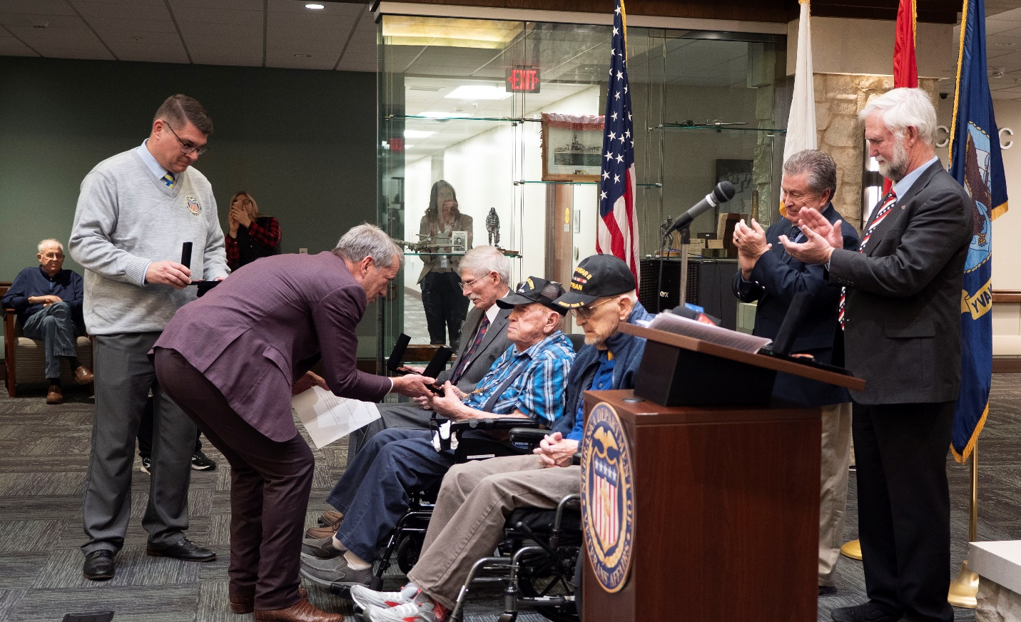
Gov. Pillen presents a recognition medal to World War II veteran Don Graper at the Central Nebraska Veterans’ Home. Seated next to him are fellow veterans Dr. John Finkner (left) and Doug Graul (right). Also pictured are NDVA Director John Hilgert (far left), Senator-elect Stan Clouse (right), and Senator John Lowe (far right).
Additional photos can be found here.
(KEARNEY, NEB.) — On December 10, Governor Jim Pillen joined Nebraska Department of Veterans’ Affairs (NDVA) Director John Hilgert in presenting World War II recognition medals to veterans living at the Central Nebraska Veterans’ Home (CNVH). The ceremony was part of Nebraska’s World War II Veteran Recognition Program that was announced earlier this year on May 8, Victory in Europe Day.
“As we approach the 80th anniversary of World War II, it’s incredible to think of what we owe these heroes,” said Governor Pillen. “Being able to present these medals to Nebraska’s World War II veterans is an incredible honor and privilege for me, and I’m looking forward to meeting more of them, hearing their stories, and thanking them for their service as we recognize them for everything they’ve done for this country.”
Veterans honored at CNVH include Dr. John Finkner of Minden, Don Graper of Gibbon, Doug Graul of Fairbury, and Elmer Heeren of Hastings.
The medal was created by the State of Nebraska and designed by NDVA to honor living World War II veterans. It is available to living veterans who served in the U.S. Armed Forces between December 1, 1941, and December 31, 1946; are legal residents of Nebraska or can demonstrate Nebraska residency at the time they entered the service; and discharged under conditions other than dishonorable.
Applicants can choose to receive their medal at an in-person ceremony at the Nebraska State Capitol on May 8, 2025; through their Mayor's Office in participating cities and towns, or by having them shipped or delivered to their home. Eligible veterans are encouraged to apply at veterans.nebraska.gov/ww2. There is no deadline to apply.
NDVA recently received the medals and is beginning to distribute to those who have already applied, including those residing at the state’s four veterans’ homes.
“Our goal is to thank and recognize every Nebraska veteran of World War II,” said NDVA Director John Hilgert. “Their service, sacrifice, and stories are important, and I would encourage anyone who knows a World War II veteran—whether it’s a family member, friend, neighbor, or someone else—to share this program with them and help them apply to be recognized for their service.”
NDVA’s mission is to honor Nebraska veterans and their families by providing excellent service, assistance, and care. Its state service office helps veterans identify and access federal benefits, such as disability compensation and healthcare through the U.S. Department of Veterans Affairs, and state benefits, such as Nebraska Veterans Aid funds, tuition waivers, and more. Its four state veterans’ homes offer high quality assisted living and skilled nursing care to veterans and eligible family members across the state. And its cemetery system ensures eligible veterans receive an honorable final resting place maintained to the highest national standards. To learn more about NDVA and how it serves Nebraska’s veterans and their families, please visit veterans.nebraska.gov.
###

