**FOR IMMEDIATE RELEASE**  
AUGUST 1, 2024

**Contact:**  
Holden Armstrong, NDVA Communications Director  
402-219-1704, [holden.armstrong@nebraska.gov](mailto:holden.armstrong@nebraska.gov)

Nebraska State Capitol to Shine Purple on   
Purple Heart Day

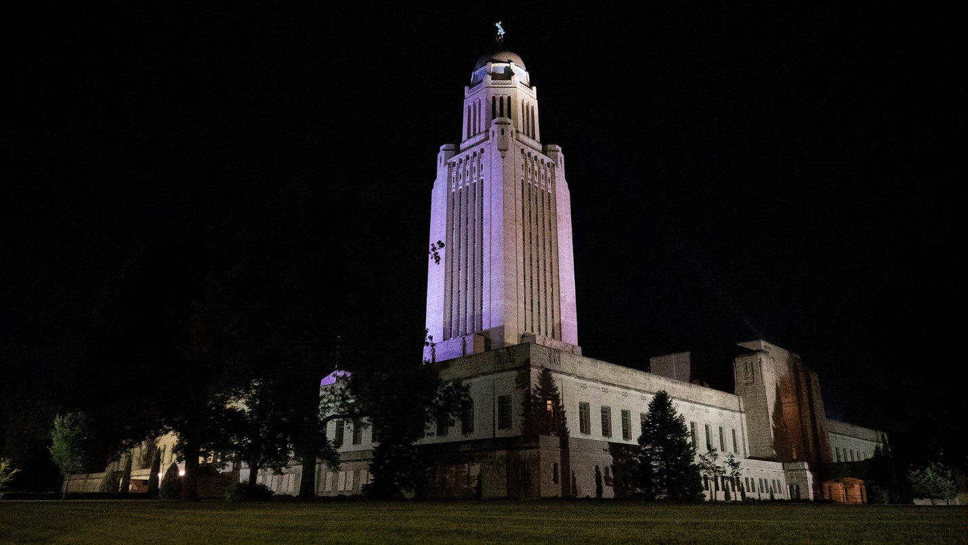*The Nebraska State Capitol lit purple for Purple Heart Day in 2022.*

(LINCOLN, NEB.)— In honor of Purple Heart Day, the Nebraska State Capitol will be illuminated in purple light on August 7, weather permitting. In addition, a proclamation recognizing Purple Heart Day in Nebraska will be signed by Governor Pillen on August 19.

“Everyone who answers the call to protect our nation sacrifices something, but for some that sacrifice is a physical, perhaps even mortal, wound,” said Nebraska Department of Veterans’ Affairs (NDVA) Director John Hilgert. “Purple Heart Day reminds us all of the very real, very serious dangers our servicemembers face. Today is about honoring their sacrifices and cherishing what we have because of it.”

First observed in 2014, Purple Heart Day is meant to honor and recognize the more than 1.8 million service members who have been awarded the Purple Heart. Originally created by George Washington as the Badge of Military Merit, the Purple Heart is the United States’ oldest military award. It is awarded to service members who are wounded or killed while serving in the U.S. Armed Forces.

NDVA’s mission is to honor Nebraska veterans and their families by providing excellent service, assistance, and care. Its state service office helps veterans identify and access federal benefits, such as disability compensation and healthcare through the U.S. Department of Veterans Affairs, and state benefits, such as Nebraska Veterans Aid funds, tuition waivers, and more. Its four state veterans’ homes offer high quality assisted living and skilled nursing care to veterans and eligible family members across the state. And its cemetery system ensures eligible veterans receive an honorable final resting place maintained to the highest national standards. To learn more about NDVA and how it serves Nebraska’s veterans and their families, please visit [veterans.nebraska.gov](https://veterans.nebraska.gov).

###