FOR IMMEDIATE RELEASE
JUNE 6, 2024
Contact:
Holden Armstrong, NDVA Communications Director
402-219-1704, holden.armstrong@nebraska.gov

Ribbon Cutting Held for new Honor Neighborhood at Eastern Nebraska Veterans’ Home
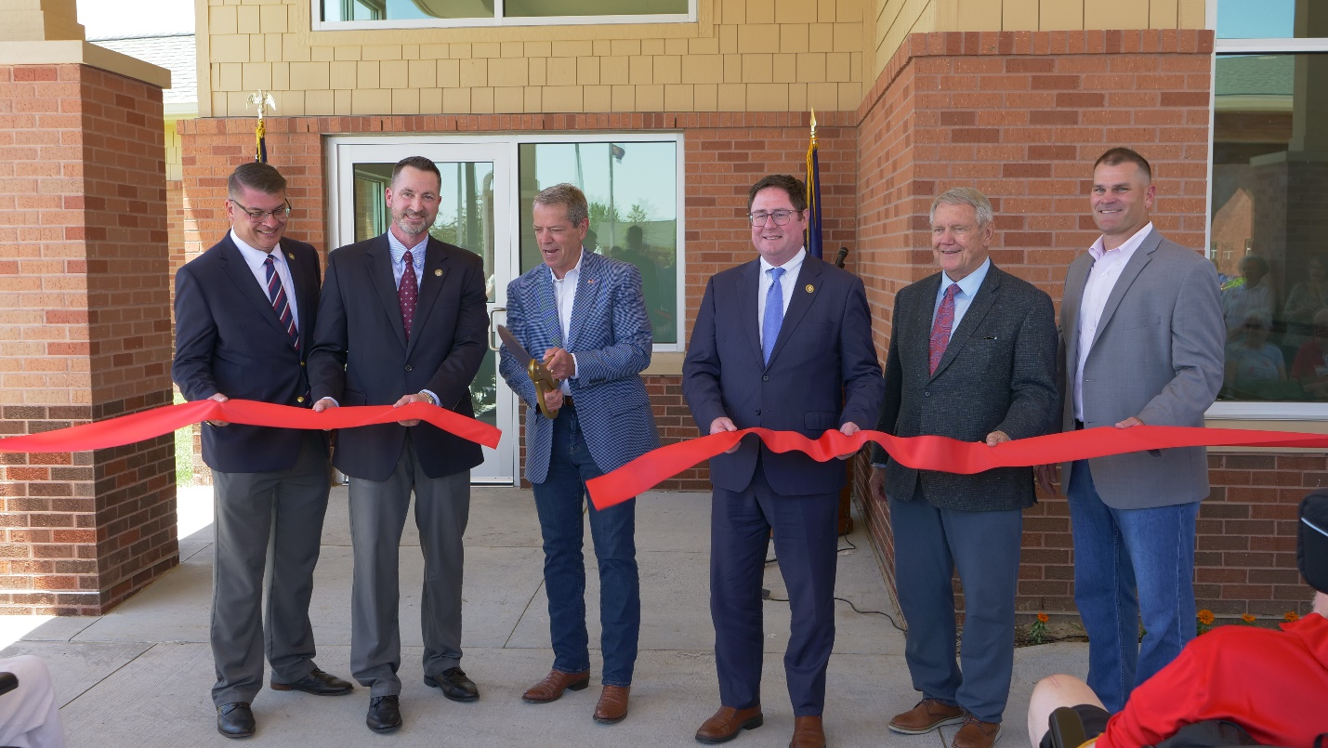From left to right, NDVA Director John Hilgert, ENVH Administrator Matt Bauman, Governor Jim Pillen, U.S. Congressman Mike Flood, Veterans Homes Board Chair Jim Cada, and DAS Director Jason Jackson cut the ribbon in front of ENVH’s new Honor neighborhood. View additional photos of the ribbon cutting here.
JUNE 6, 2024 (BELLEVUE, NEB.) — This afternoon Governor Jim Pillen, Nebraska Department of Veterans’ Affairs (NDVA) Director John Hilgert, and other officials and partners hosted a ribbon cutting and open house for the new Honor neighborhood at the Eastern Nebraska Veterans’ Home (ENVH).

“One of my greatest privileges is meeting veterans and their families across our great state,” said Governor Pillen. “Veterans have selflessly served to protect our way of life, and we have a duty to repay them. Today’s ribbon cutting showcases Nebraska’s commitment to repaying those who’ve served.”

Honor neighborhood adds nearly 25,000 square feet to the facility, bringing ENVH to just under 150,000 square feet. It includes 24 single-occupancy rooms with assisted living beds as well as space for a new Adult Day Health Care Medical Model program. Members living in Dedication neighborhood will soon begin moving into Honor, at which point a remodel of Dedication will begin to convert its 30 assisted living beds into skilled nursing beds. Once completed, the project will bring the facility’s licensed capacity to 144.

“Our agency is here to serve Nebraska’s veterans and their families,” said NDVA Director Hilgert. “This expansion and remodel will allow us to provide care to more members and offer an entirely new service for those who need something in between 24-hour care and in-home living. It’s an exciting day for NDVA, the state of Nebraska, and those who have served our nation.”

The Department of Administrative Services’s State Building Division worked with the architect on the design of the expansion and managed the construction of the building. SBD Administrator Brent Flachsbart said, “As a veteran, it was a privilege for me and my team to be involved with the expansion of the Eastern Nebraska Veterans’ Home and the construction of the new Honor Neighborhood.”
NDVA operates four state veterans’ homes, located in Bellevue, Kearney, Norfolk, and Scottsbluff. They offer assisted living, skilled nursing, and memory care to Nebraska veterans, spouses, surviving spouses, and Gold Star parents. To learn more about NDVA’s veterans’ homes, view virtual tours of the facilities, and apply for admission, please visit veterans.nebraska.gov/homes.
###

