FOR IMMEDIATE RELEASE
May 9, 2024
Contact:
Holden Armstrong, Communications Director
402-219-1704, holden.armstrong@nebraska.gov
Gov. Pillen, NDVA Announce World War II Veteran Recognition Program
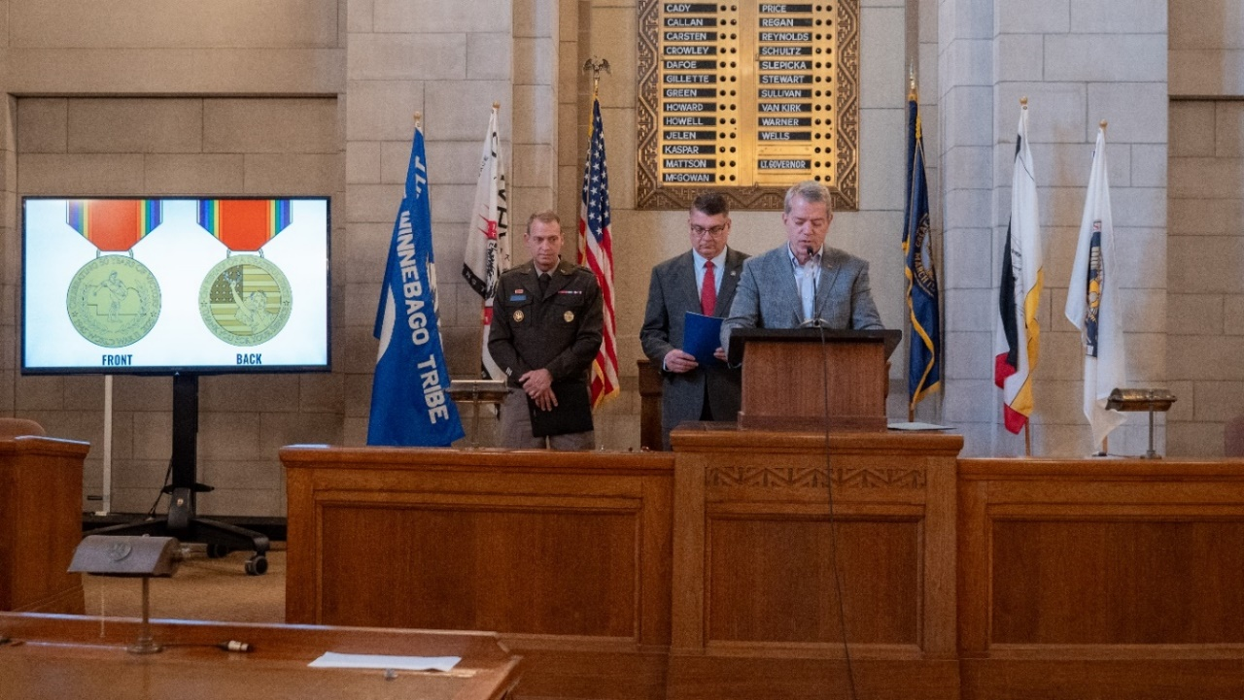
Nebraska’s World War II Recognition medal design was revealed by Gov. Pillen (right) during the Victory in Europe Day proclamation ceremony, where he was joined by Nebraska Adjutant General Maj. Gen. Craig Strong and NDVA Director John Hilgert (left to right). View additional photos here.
LINCOLN, NEB. — Applications are now open for Nebraska’s World War II Veteran Recognition Program, an initiative from Governor Jim Pillen and the Nebraska Department of Veterans’ Affairs (NDVA) to recognize Nebraska’s living World War II veterans in 2025 for the 80th anniversary of the end of the war. The application and information on the program are available at veterans.nebraska.gov/ww2.

“Those who fought in World War II are known as the greatest generation because of their sacrifice and determination to overcome an evil that threatened to overtake the world,” said Gov. Pillen. “Our state recognition program is a small, but important, token of our undying appreciation. But for our veterans and their families, we would not be here enjoying the freedoms that we experience every day.”

The medal is available to living veterans who served in the U.S. Armed Forces between December 1, 1941, and December 31, 1946; are legal residents of Nebraska or can demonstrate Nebraska residency at the time they entered the service; and discharged under conditions other than dishonorable.

“The goal of this program is two-fold,” said NDVA Director John Hilgert. “One, we want to thank Nebraska’s World War II veterans while we still can and recognize them for their tremendous sacrifice at a turning point in world history. Two, we want to refocus our attention to these veterans and their stories to remind people of what they were fighting for and just how much they sacrificed to fight for it.”

In-person medal presentation ceremonies at the Nebraska State Capitol are set for Victory in Europe Day, May 8, and Victory over Japan Day, September 2, 2025. Gov. Pillen and NDVA are also encouraging mayors across the state to assist by hosting their own 80th anniversary ceremonies to present medals to local WWII veterans in an effort to present as many medals in-person as possible. Veterans may also choose to receive their medal via mail, with medals expected to ship in late 2024 to early 2025.

The announcement took place at the May 8 proclamation signing ceremony for the 79th anniversary of Victory in Europe Day. Gov. Pillen and NDVA Director Hilgert were joined by Nebraska Adjutant General Maj. Gen. Craig Strong. He spoke of his recent trip to the Czech Republic for the city of Pilsen’s annual Liberation Festival, honoring the U.S. soldiers who helped rescue it from Nazi control, and of the Nebraska National Guard’s role in liberating several French cities during World War II.

“Many wearing our nation’s uniform today would not be doing so without the role models of those who served before us,” Maj. Gen. Craig Strong said. “World War II Veterans deserve to be recognized with this medal, and this commemoration will go a long way in preserving the memory and legacy of these great heroes.”
Video from the ceremony is available here.

NDVA’s mission is to honor Nebraska veterans and their families by providing excellent service, assistance, and care. Its state service office helps veterans identify and access federal benefits, such as disability compensation and healthcare through the U.S. Department of Veterans Affairs, and state benefits, such as Nebraska Veterans Aid funds, tuition waivers, and more. Its four state veterans’ homes offer high quality assisted living and skilled nursing care to veterans and eligible family members across the state. And its cemetery system ensures eligible veterans receive an honorable final resting place maintained to the highest national standards. To learn more about NDVA and how it serves Nebraska’s veterans and their families, please visit veterans.nebraska.gov.
###

