FOR IMMEDIATE RELEASE
SEPTEMBER 30, 2024
Media Contact:
Holden Armstrong, NDVA Communications Director
402-219-1704
holden.armstrong@nebraska.gov

NDVA Hosts 3rd Annual Nebraska Women Veterans Symposium
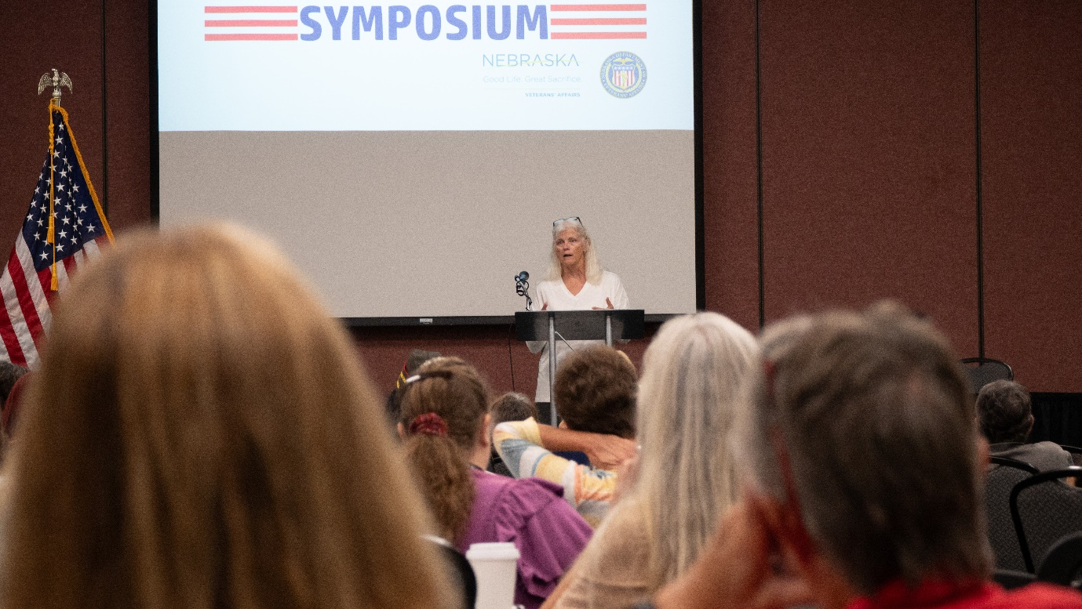
Retired Major General Mary Link gives keynote remarks at the 2024 Nebraska Women Veterans Symposium Additional symposium photos are available here.
KEARNEY, NEB. – The Nebraska Department of Veterans’ Affairs (NDVA) hosted its 3rd annual Nebraska Women Veterans Symposium September 28 and 29 in Kearney. Over 100 women veterans from nearly 40 different Nebraska cities and towns attended the free two-day event to learn about veteran benefits, connect with community resources, and network with fellow women veterans.

“Every year this symposium reminds me of how many people and organizations truly care about our women veterans and want to support them however they can,” said NDVA Women Veterans Coordinator Erin Colson. “We want our women veterans to know there are resources available for them and their families, NDVA is here to recognize and support them, and their fellow women veterans are here to uplift and empower them.”

The symposium featured a keynote from retired Major General Mary Link, former commanding general of the Army Reserve Medical Command. She summarized her extensive military career and shared some of the advice she learned during her over three decades of service. Other presenters included Lourdes Tiglao, executive director of the Center for Women Veterans, who traveled from Washington, DC, to speak at the event, as well as a range of representatives from U.S. Department of Veterans Affairs (VA) departments and programs, including Nebraska-Western Iowa Health Care System, Suicide Prevention, MOVE! Program, Veteran Readiness and Employment, Whole Health, and Veterans Benefits Administration. New Century Art Guild was on hand for a tie-dyeing activity.

“Our women veterans symposium has continued to grow each year, both in the number of attendees and the amount of resources and information provided,” said NDVA Director John Hilgert. “I’m proud of the work our agency has done to reach out to serve the ever-increasing number of women who serve in our armed forces. We are here to serve all of Nebraska’s veterans, and getting out and hosting events like this symposium is an important component in ensuring we do that.”

An exhibitor area at the symposium featured representatives from the presenting organizations as well as other veterans service organizations and non-profits with resources to share with veterans. This included American Legion Department of Nebraska, Veterans of Foreign Wars (VFW) Department of Nebraska, Disabled American Veterans, Central Nebraska Community Action Partnership, Nebraska Arts Council, Drug Enforcement Administration, Warrior Writers, PGA Hope, JAVELAN, AARP, Dog Tags Garage, At Ease USA, HeArts for Healing, and Brain Injury Alliance.

Financial support for the conference came from VFW Department of Nebraska, Wounded Warrior Family Support, Girl Scout Troop 48692, and Shadow Anesthesia Services.

NDVA’s mission is to honor Nebraska veterans and their families by providing excellent service, assistance, and care. Its state service office helps veterans identify and access federal benefits, such as disability compensation and healthcare through the U.S. Department of Veterans Affairs, and state benefits, such as Nebraska Veterans Aid funds, tuition waivers, and more. Its four state veterans’ homes offer high quality assisted living and skilled nursing care to veterans and eligible family members across the state. And its cemetery system ensures eligible veterans receive an honorable final resting place maintained to the highest national standards. To learn more about NDVA and how it serves Nebraska’s veterans and their families, please visit veterans.nebraska.gov.
###

